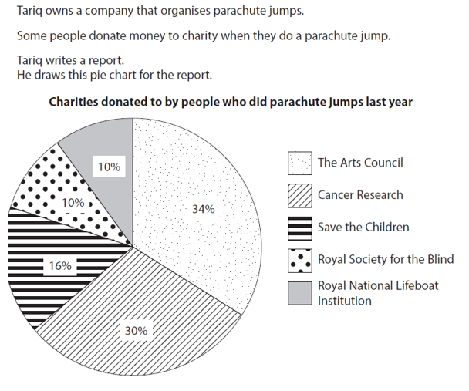

Tariq states that a 1/3 of of the donations went to cancer research, is he correct?
Explain your answer below

- Jane wants to buy a barbecue. She sees this offer
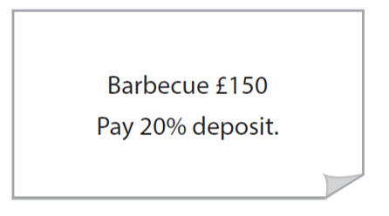

Work out 20% of £150 for Jane.

- There are 6000 bees in the behive. 15% of the bees in the beehive are male bees.
Alia thinks there are 900 male bees in the beehive.
Is Alia correct?

- In the hotel Winston and Karen see this offer
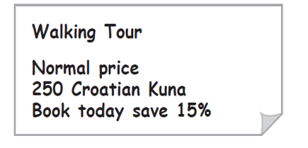

Work out 15% of 250

- Caz is offered a new contract at work. He can choose how he wants to be paid.

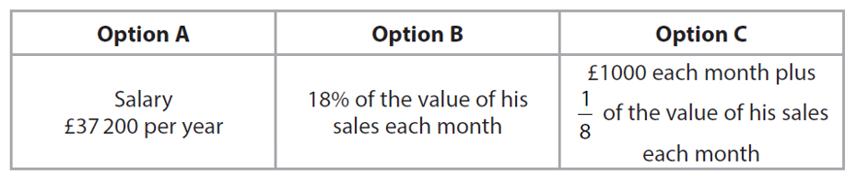

Caz expects to make sales of 21500 each month
He wants to be paid as much as possible.
Which option shouold caz choose.
Show why you think this

- Freya is the production manager.
There are 125 staff making food at polar frozen foods.
Each of them works 35 hours a week.

Freya is going to raise the hourly rate of these staff from £7.20 per hour to £8.25 per hour.
She also wants to increase the number of staff making food by 8%
They will be paid £8.25 per hour and will also work 35 hours a week.

Calculate the increase in the total amount of money the company will have to pay the staff making food each work.

Clearly show your answer below.

