Probability Facts
Probability is the mathematical chance of an event happening.
Probability = number of successful outcomes
Total number of possible outcomes

Outcome - all the possibilities from an action e.g. throwing a six sided die will give outcomes of 1, 2, 3, 4, 5 and 6
Event – something that can happen e.g. throwing a 6 on a die, flipping a coin and getting a tail
Certain - the probability of an event happening is equal to 1.

Equally Likely or Evens – there is a probability of ½ or 0.5 or equal chance that an event will happen.
Impossible – the probability that an event happens is zero.
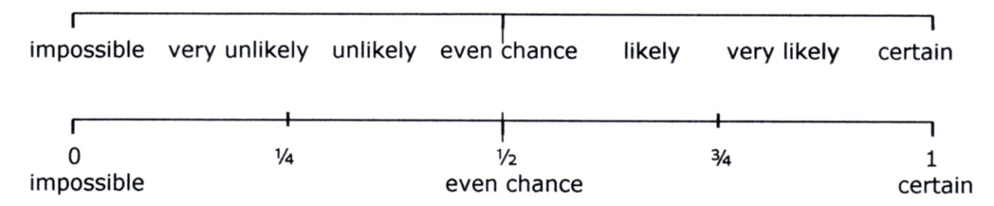
Probability Scale - the probability scale is between 0 and 1 (or 100%) and can be expressed as a decimal, percentage or a fraction but, NOT as a ratio or betting odds.

Fair - there is an equal chance of all events happening, e.g. the probability of throwing any number on a fair die is equally likely i.e. $\frac{1}{6}$
Bias - the chance of an event happening is not fair e.g. a die may be weighted on one side which will affect the probability of the numbers being thrown.
Experiment - an activity where results can be observed and recorded, e.g. throwing a dice 60 times and recording the outcomes.
Experimental Probability – the chance that there will be a particular outcome from an experiment, e.g. the number of times a 6 is thrown on a dice out of 60 throws. This is also known as relative frequency.
Relative Frequency = the number of times an event happens
the number of attempts
Theoretical or Expected Probability – is the probability that an event will happen e.g. we would expect the probability of throwing a head or a tail on a fair coin to be ½. However, the actual outcome over a number of throws may not match the expected probability exactly.
Sample Space Diagram – a table to organise possible outcomes to calculate probability e.g. a “sample space diagram” for throwing a coin and a dice:
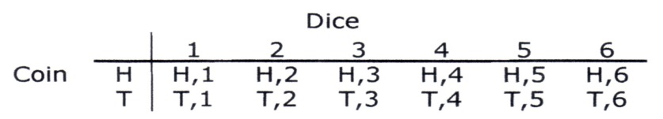

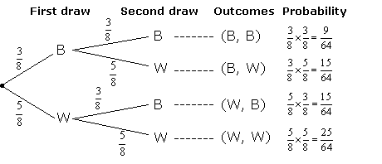
Tree Diagram – helps organise choices and calculate probability, e.g. the probability of picking different combinations of black and white balls from a bag with 3 black balls and 5 white balls.

With Replacement - if picking coloured balls from a bag and replacing them each time then the probability of picking a specific colour at each stage will remain the same because there is always the same number of balls in the bag.
Without Replacement - if picking coloured balls from a bag and the ball picked is not replaced then the probability of the next ball being a certain colour will be affected - see Dependent Events example.
Independent Events - if 2 events are independent of one another this means that the probability of the second event happening is not affected by the outcome of the first event. An example could be spinning a spinner and flipping a coin. The outcome from spinning the spinner does not affect whether a head or tail is thrown when flipping a coin.
Dependent Events - the probability of an event is affected by previous events e.g. picking coloured balls from a bag without replacement. If a black ball is picked and not replaced from a bag with 5 black balls and 5 white balls, the probability of getting a black ball on the second pick will change from ½ to 4/9 and the probability of picking a white ball will change from ½ to 5/9.
Mutually Exclusive Events - these events cannot happen at the same time e.g. a head and a tail cannot be obtained from flipping one coin.

