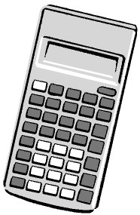
Candidate surname
Other names
Total Marks
Centre Number
Candidate Number
Please check the examination details below before entering your candidate information
You must have:
Pen, calculator, HB pencil, eraser, ruler graduated in cm and mm,
protractor, pair of compasses. Tracing paper may be used.
Paper Reference
PMAT2/C08
Time: 1 hour 30 minutes
Mathematics
Level 2
Section B (Calculator)
Pearson Edexcel
Functional Skills
Set 8
My signature confirms that I will not discuss the content of the test with anyone.
Signature:

Instructions
- • Use black ink or ball-point pen.
Fill in the boxes at the top of this page with your name,
- • • • • Sign the declaration. centre number and candidate number.
Answer all questions.
Write your final answers in the boxes provided.
Answer the questions in the spaces provided – there may be more space than you need.
You must show clearly how you get your answers in the spaces provided. Marks will be
awarded for your working out.
- • • • Check your working and answers at each stage.π π
Diagrams are not accurately drawn, unless otherwise indicated.
Calculators may be used.
If your calculator does not have a button take the value of to be 3.14

Information
- • • The total mark for this section is 48.
The total mark for this paper is 64.
The marks for each question are shown in brackets
- This signshows where marks will be awarded for showing your checks. – use this as a guide as to how much time to spend on each question.

Advice
• • Read each question carefully before you start to answer it. Check your answers if you have time at the end.
Turn over

^{P68471A} *P68471A0120*
©2021 Pearson Education Ltd. 1/1/1/1/1/1
SECTION B
Answer ALL questions. Write your answers in the spaces provided.
1 Mandy spins a fair spinner twice.
The colours on the spinner are red, blue, green, orange and pink. The table shows all the possible outcomes.
Second spin
 | Red | Blue | Green | Orange | Pink
Red | R, R | R, B | R, G | R, O | R, P
Blue | B, R | B, B | B, G | B, O | B, P
Green | G, R | G, B | G, G | G, O | G, P
Orange | O, R | O, B | O, G | O, O | O, P
Pink | P, R | P, B | P, G | P, O | P, P
First spin
(
a)
What is the probability of getting the same colour on both spins?

(1)
(
b) What is the probability of getting at least one blue in the two spins?

(2)
(
Total for Question 1 is 3 marks
)

*P68471A0220*
- Habiba wants to make pastry by mixing butter and flour.
She needs to mix the butter and the flour in the ratio 4 : 9

Habiba wants to make 650 grams of pastry.

She has 425 grams of flour.
Does Habiba have enough flour to make 650 grams of pastry?
Show why you think this.

(3)
(
Total for Question 2 is 3 marks
)

*P68471A0320*
- Habiba also wants to make cupcakes. She has this list of ingredients.
Cupcakes
makes 12
2
cups of flour
3
tbsp butter
cup sugar
pinch of cinnamon
1
egg
10.5
fl oz milk
3
apples
3
4
Habiba wants to make 30 cupcakes.

1
fl oz = 28.413 ml
How much milk does Habiba need to make 30 cupcakes?
Give your answer to the nearest ml.

(4)
(
Total for Question 3 is 4 marks
)
ml

*P68471A0420*
- Callum is a plumber.
He spends money on eight different adverts.
Callum has this information about the money he spent on each advert and the number of new customers from seeing that advert.
Money spent (£) | 100 | 175 | 80 | 250 | 150 | 325 | 125 | 290
Number of new customers | 7 | 12 | 4 | 16 | 8 | 23 | 9 | 18
Callum wants to draw a diagram to see if there is a relationship between the money he spent on each advert and the number of new customers from seeing that advert.
Draw a suitable diagram for Callum.

(3)
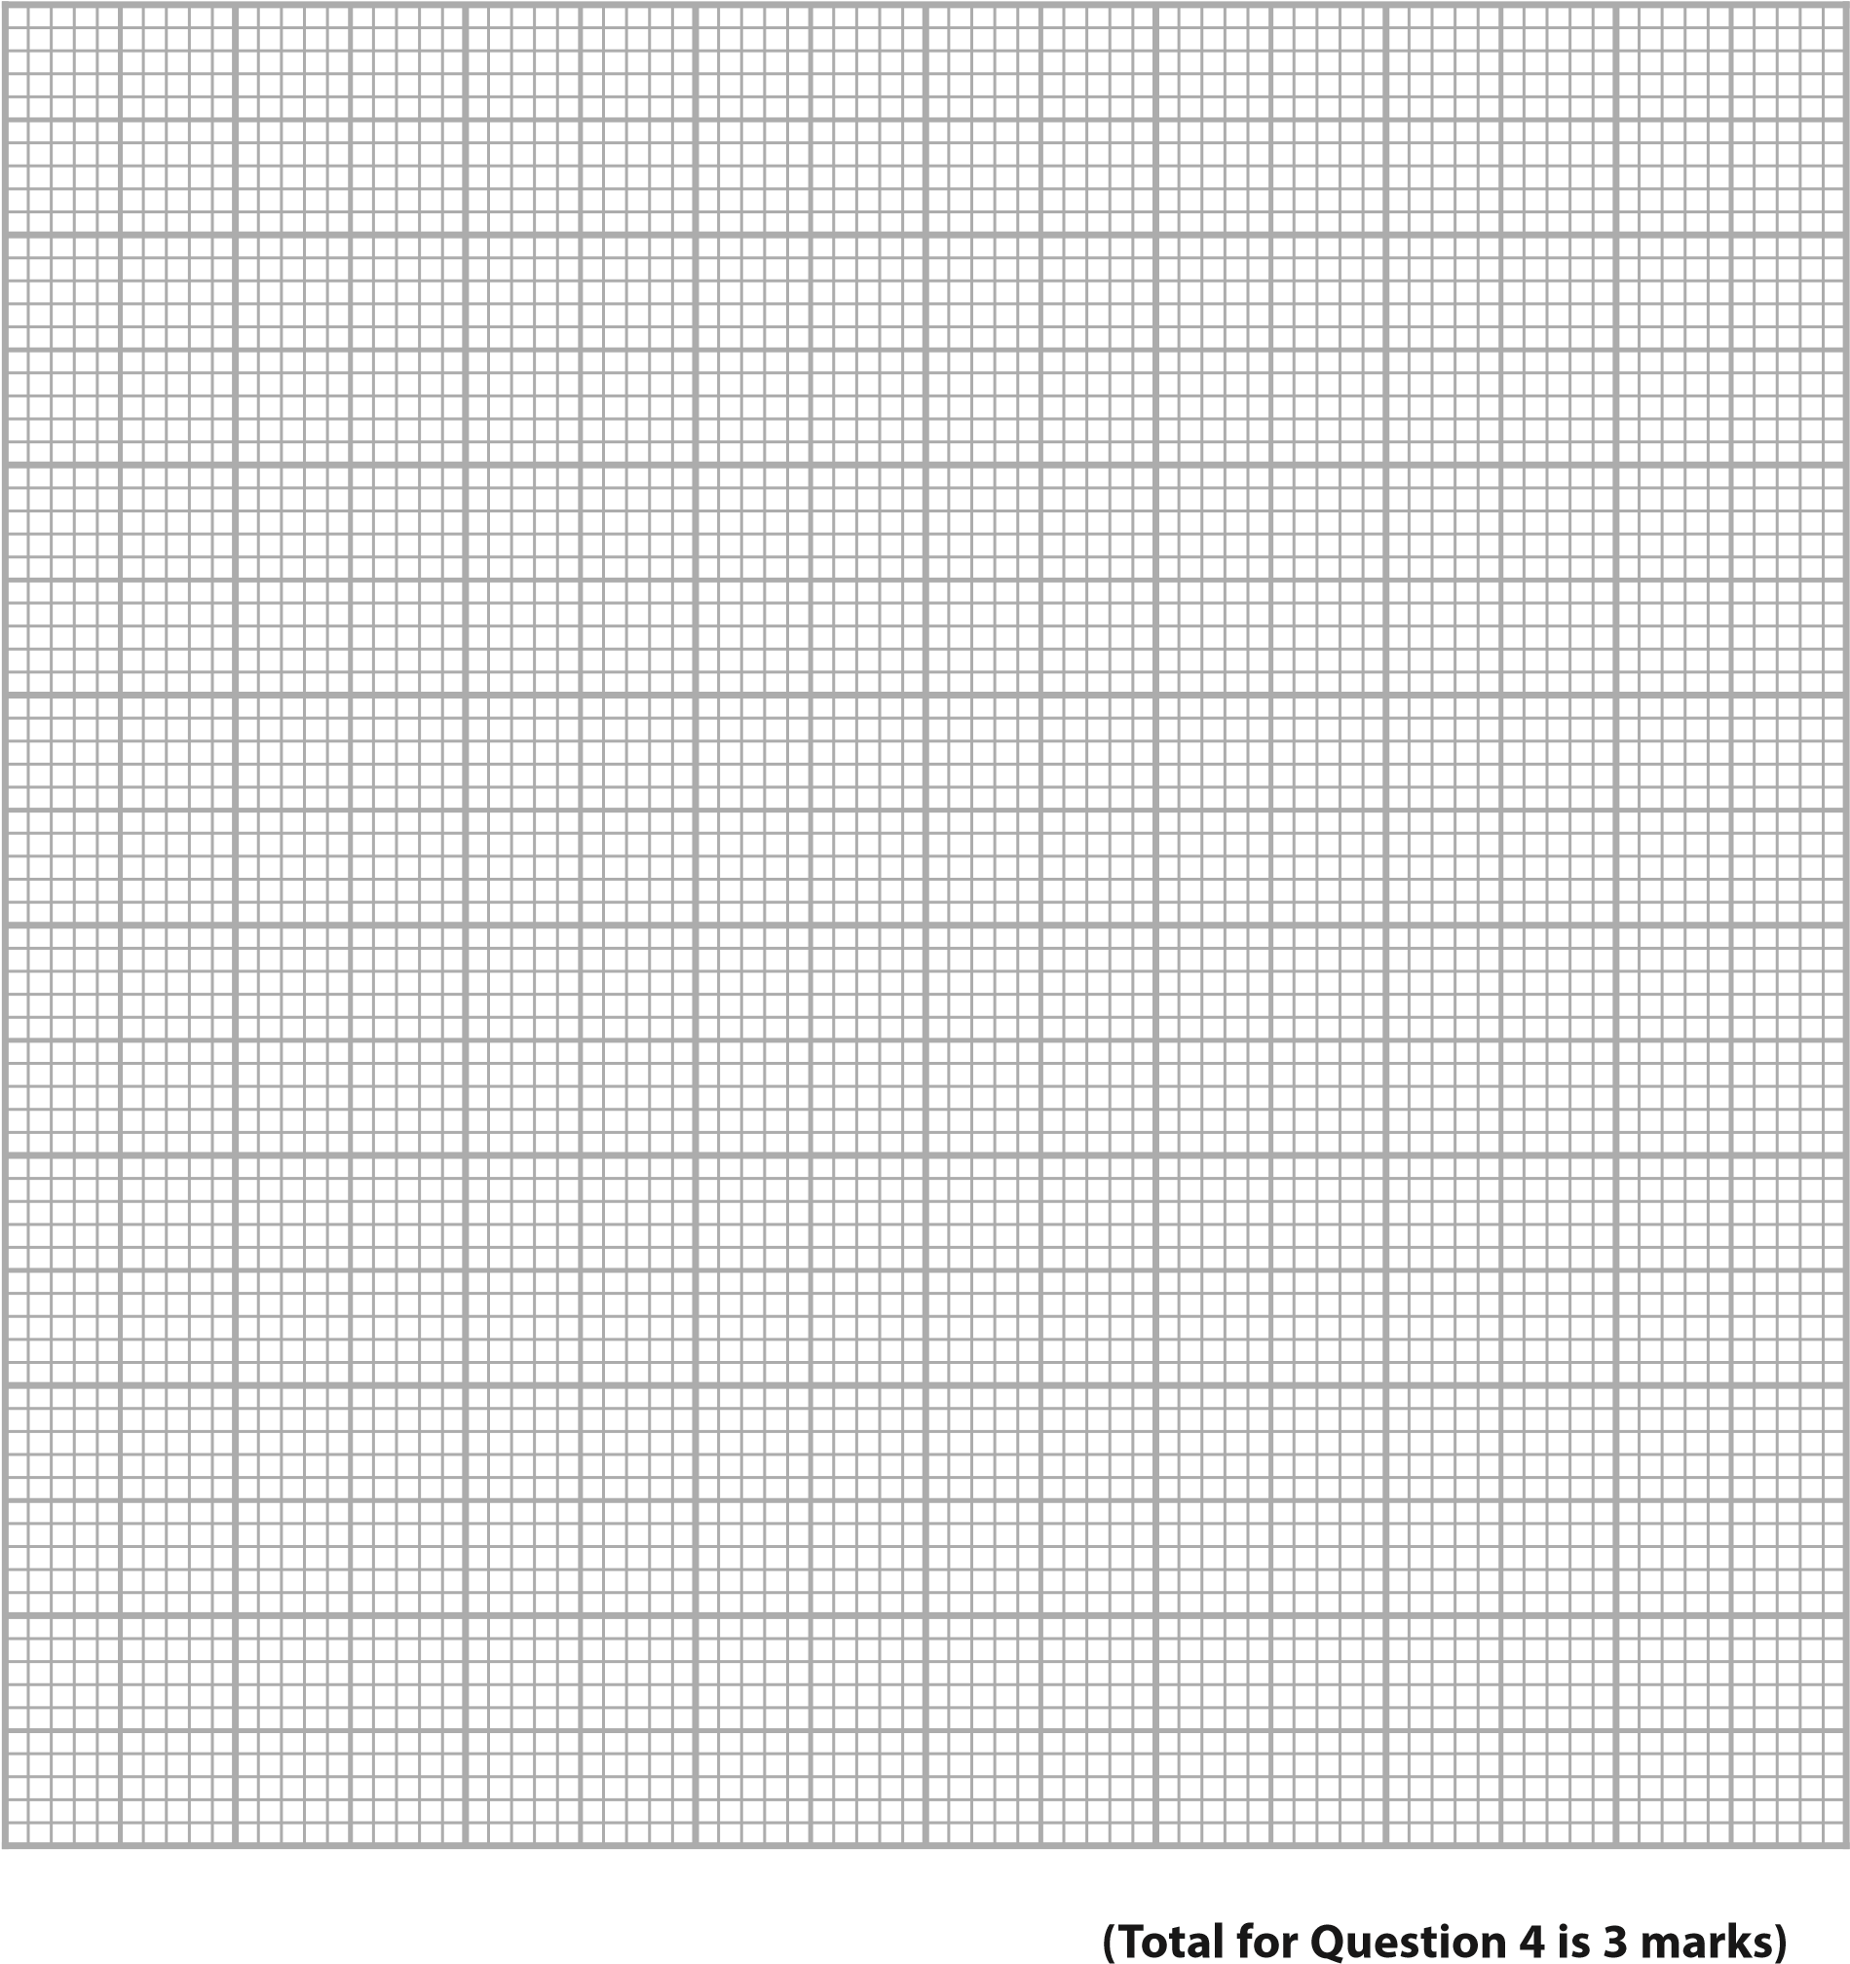

*P68471A0520*
5 Misha rows in a team of 8 people.
She wants to compare the mean BMI of the people in the rowing team with the mean BMI of women in the UK.
Misha uses this formula to calculate her BMI.
W
BMI = ₂
H
W is weight (kg)
H is height (metres)
Misha has a weight of 73.3 kg and a height of 67 inches.
1 inch = 2.54 cm
The table shows some information about the BMIs of the people in the rowing team.
Louise | Katia | Leila | Lisa | Gemma | Mel | Steph | Misha
24.8 | 27.1 | 25.7 | 28.3 | 26.4 | 25.2 | 27.6 | ……
The mean BMI of women in the UK is 26.9
Compare the mean BMI of the people in the rowing team with
the mean BMI of women in the UK.

(5)

*P68471A0620*
(
Total for Question 5 is 5 marks
)

*P68471A0720*
6
(
a)
Write three million, six hundred and seventy five thousand in figures.

(1)
(
b) Write 760 grams as a fraction of 1 kilogram.

Give your answer in its simplest form.

(2)
(
Total for Question 6 is 3 marks
)

*P68471A0820*
7 Nyam looks at the screen time report on his phone.
This week his average screen time per day is 28% greater than his average screen time per day last week.
This week Nyam’s average screen time per day is 3 hours and 44 minutes.
Work out Nyam’s average screen time per day for last week.

(4)
(
Total for Question 7 is 4 marks
)

*P68471A0920*
8 Frank wants to fit underfloor heating in his kitchen. The kitchen is in the shape of a rectangle.
He has this sketch.
600

mm
4.5

m
floor
space
3.6 m
The shaded space shows the part of the floor covered by cabinet bases. Each cabinet has a depth of 600 mm.
Frank will cover part of the floor space with heating cable.
Frank needs to leave a gap of 100 mm between the base of the cabinets and the part of the floor space he will cover.
He needs to buy a cable pack.
The table shows information about the different sizes of heating cable packs and the maximum floor area each pack can cover.
Cable pack size | Maximum floor area (m²) | Cost (£)
small | 4.2 | 109.99
medium | 6.0 | 164.99
large | 8.4 | 179.99
extra large | 10.6 | 199.99
Frank wants to spend as little as possible.

*P68471A01020*
(
a)
Work out the cost of the cable pack Frank needs to buy.

You
must
show your working.

(5)
£
(
b) Use a reverse calculation to show a check of your answer.

(1)

(
Total for Question 8 is 6 marks
)

*P68471A01120*
9 Sammi has designed a sweet tin in the shape of a cylinder.
The plan and the front elevation of the tin are shown on the centimetre grid below.
plan
front
Find the volume of the sweet tin.

(3)
(
Total for Question 9 is 3 marks
)
cm
3

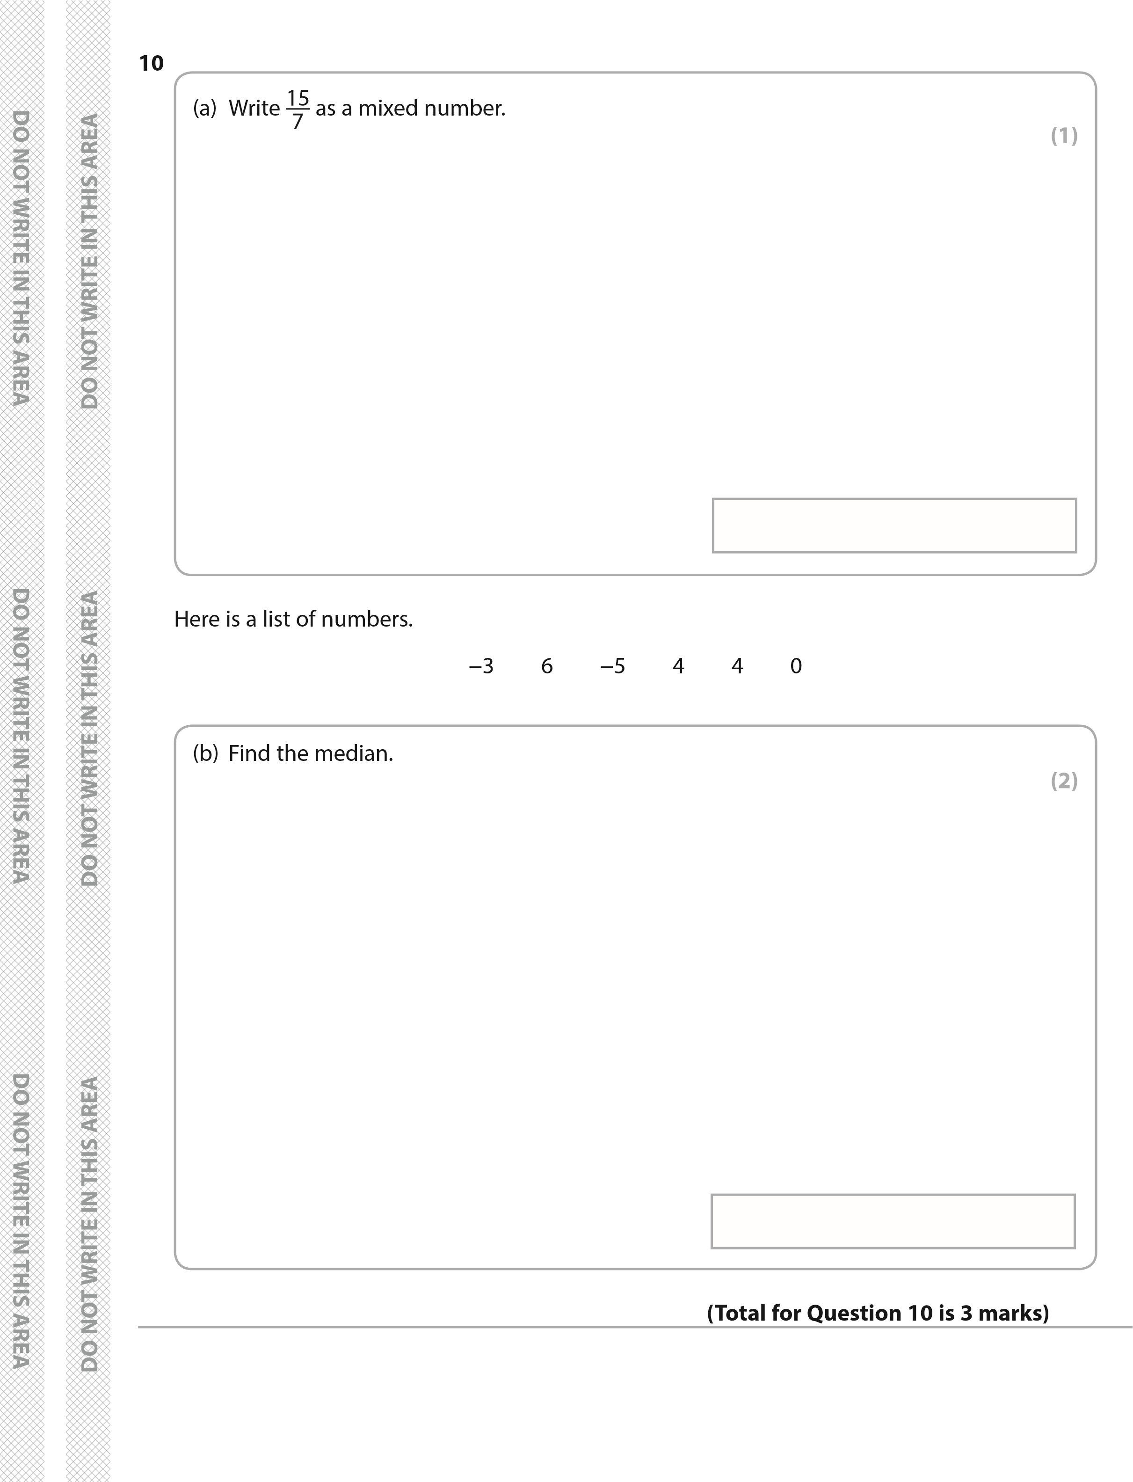
*P68471A01220* *P68471A01320*
11
(
a)
Write 28% as a decimal.

(1)
Andrew pays 38.90 euros for a meal in Spain using his British bank card.
The British bank charges a fee for changing currency. The fee is 2.75% of the amount he pays for the meal.

£1 = 1.127 euros
(
b) Work out the total amount Andrew pays for the meal and the fee.

Give your answer in pounds.

(4)
*P68471A01420*
£
(
Total for Question 11 is 5 marks
)

*P68471A01520*
12 Bilal works for a supermarket.
His usual pay is £8.70 per hour.
Bilal will work for 7 hours this Sunday.
The supermarket will pay Bilal time and a half for working on a Sunday.
Bilal thinks the supermarket will pay him more than £100 for working this Sunday.
(
a)
Is he correct?

Show why you think this.

(3)

*P68471A01620*

Mina works in a different shop.
The table shows some information about the wages for Bilal and the wages for Mina for the last six weeks.
 |  | 1 | 2 | 3 | 4 | 5 | 6
Wages (£) | Bilal | 216.43 | 283.94 | 192.87 | 221.02 | 205.48 | 186.32
Wages (£) | Mina | 296.56 | 308.71 | 188.96 | 259.32 | 126.40 | 283.21
Bilal says,
“My wages were more consistent than Mina’s wages for the last six weeks.”
(
b) Were Bilal’s wages more consistent than Mina’s wages?

Give a reason for your answer.

(3)
(
Total for Question 12 is 6 marks
)

TOTAL FOR SECTION B IS 48 MARKS
TOTAL FOR PAPER IS 64 MARKS

*P68471A01720*
BLANK PAGE

*P68471A01820*
BLANK PAGE

*P68471A01920*

BLANK PAGE

*P68471A02020*

