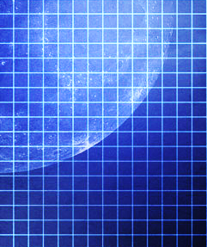
H
W
L
Difficult ??
1sq =1cm
1sq =1cm

