Discussion Table
Discuss how you would write a sum for each word problem

What division methods are you using to solve each problem and what are other people using?

Talk about whether you can do them in your head, have to write them down or have to pick up a calculator… and why!

John puts his one hundred and forty six DVDs onto five shelves so there is the same amount on each shelf. How many DVDs are there on each shelf and how many are left over?


Level 1

While watching a Saturday night movie some friends divide up some pizza. Each pizza is cut into eight slices and each person eats three slices. With thirty two slices how many friends can be fed ?
?


Level 1

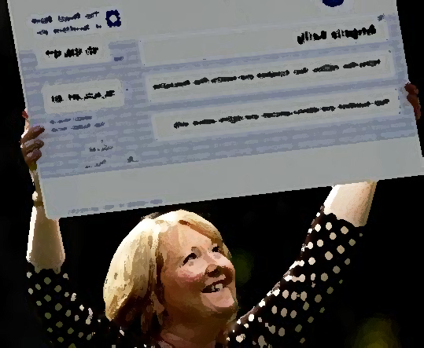
Level 2
Susan wins £14,500,000 and splits her winnings amongst her six friends in her work syndicate. How much does each person get, to the nearest penny?

I bought forty five nappies last week. The nappies I buy are packaged with fifteen nappies per pack. How many packs did I buy?

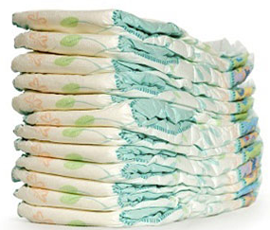

Level 1


A group of twenty seven people need to divide themselves up into three groups for a sports day tournament. How many people should be in each group?

E3



In an arcade game, alien space ships attack your ship in groups. There are twenty four alien ships on the screen and they are split into groups with six ships in each group. How many alien ships are in each group?

E3

At a local football match the spectators watch from all four sides. There are two thousand, One hundred and eighty four spectators and they are (roughly) evenly spread out along the sides. About how many are on each side?

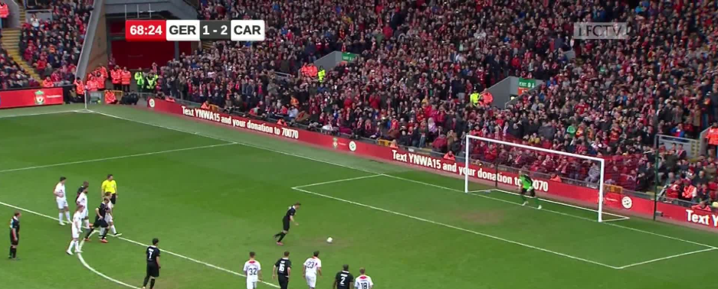
Level 1

I will pay for a new TV using instalments, paying over two years. The TV costs £1200. Find the amount per month I pay.


Level 1

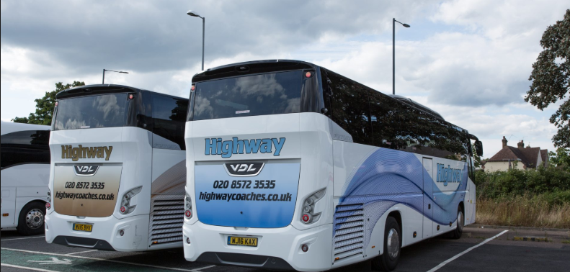
A school trip requires coaches to transport the pupils. There are 263 pupils going on the trip. Coaches hold forty five people. Find the number of coaches needed for the trip.

Level 1

A tray bake is placed in the oven which can hold cakes in three rows of six cakes. You would like to make forty cakes for a party. How many trays of cakes do you make?

Level 1

A plane completes 48,370km, journeying multiply times across Europe. How many trips of 3,500km is this?

Level 2

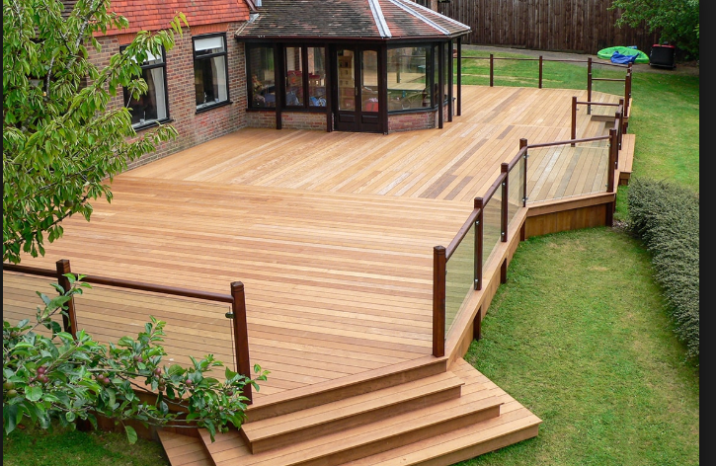
Level 1
You are planning to have new wooden decking in your garden. Each length of wood is 3m long and 20cm wide. The area needing covering is 3m wide and 10m long. How many strips of wood do you need?

Small boxes of beans are packed in the warehouse with 4 cans wide, 6 cans long and 3 layers of cans in each small box. How many of these boxes can be packed into the larger crate that holds 20 cans long, wide and high ?


Level 2


A building is 845m tall. Each floor is the same height at 3m tall except the top floor which is taller. How many floors are there in the building? How tall is the final top floor?

Level 1

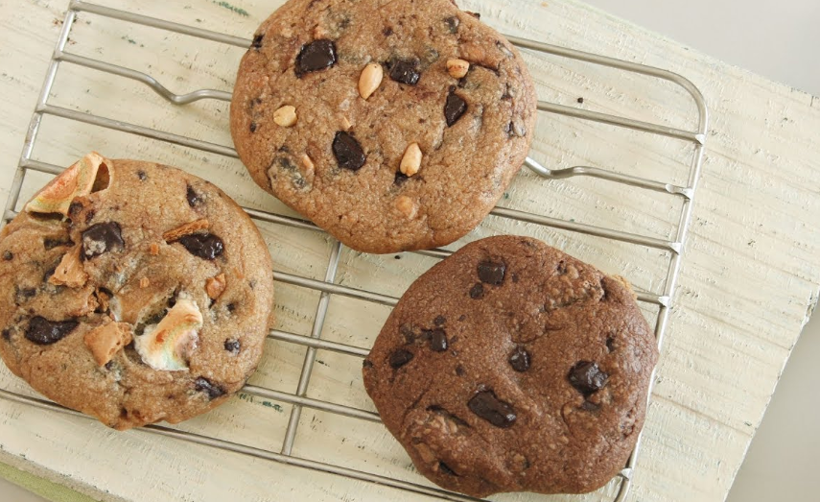
Level 1
Three cookies need to be evenly shared between… a) three b) four c) five d) six children. For each division state how much of each of the cookies the children get.
A tub of ice cream is used to fill some cones. How many 420ml ice cream cones can be filled from a tub of 3000ml ? How much ice cream is left in the tub?


Level 2

You plan to buy clothes with £150. How many £27 pairs of jeans can you buy. With what is left, how many £4 t-shirts can you buy?
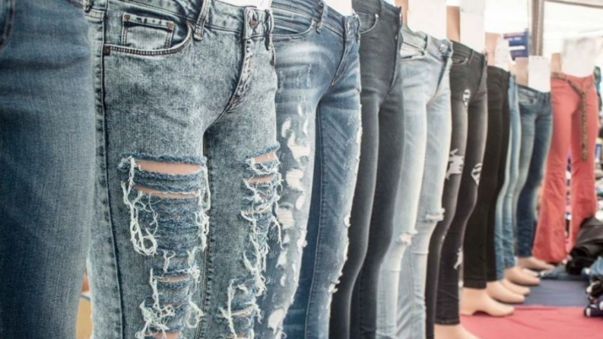
Level 2


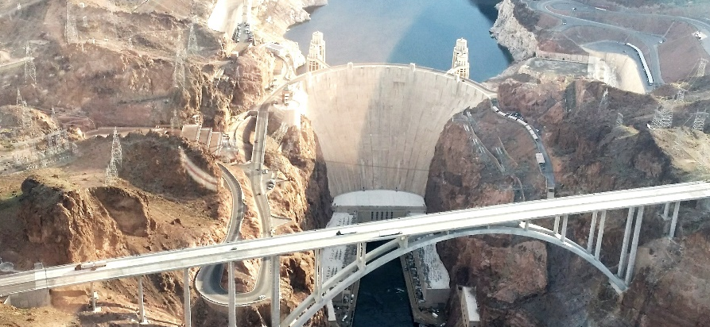
Level 2
2.78M tonnes of water pass through 6 hydro pipes each year. Find the monthly amount of water per pipe.

