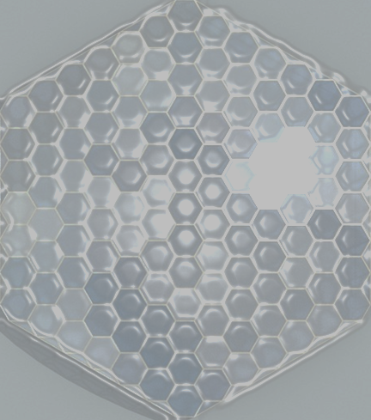
L2
L2
Manufacture:
a cube with lengths 5cm from card
How many can you make from 2mx1m sheet of card?
Manufacture:
a metal pipe 20cm long, radius 3cm
How many can you make from 1m² sheet of metal?

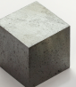
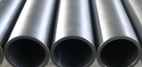
L2
L2
Manufacture:
Circular metal discs with diameter 20cm
How many can you make from 10m² sheet of metal?
Manufacture:
a square tile, 1 foot square
How many tiles do you need to fill the room you are in?

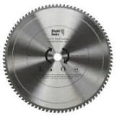
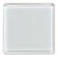
L2
L2
Manufacture:
a cubiod shaped box, 20cmx10cmx5cm
How many square inches are there in the card area used?
Manufacture:
a die using card with side lenghts 2cm
How many can you make from a single A4 sheet of card?

