
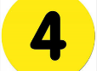
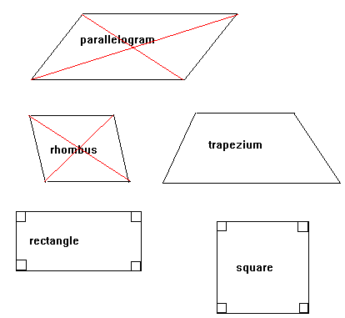
Discuss which shapes have lines of symmetry.
Which have parallel lines?
What shapes do you know, sides, corners?

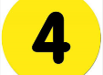
Sides
Faces
Corners

Sid
Symmetry
Parallel
Polygon
Angles

Quadrilaterals
Labelling

Do you recognise all these words? Test each other…draw out some shapes and name them and their properties

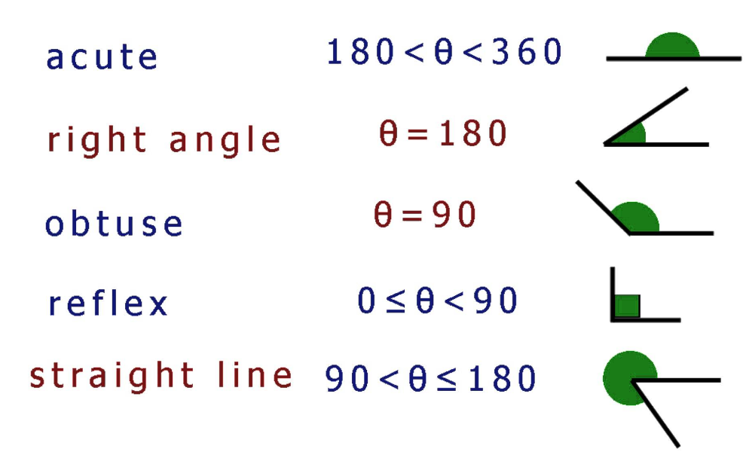



Everything’s wrong above.. isn’t it ?

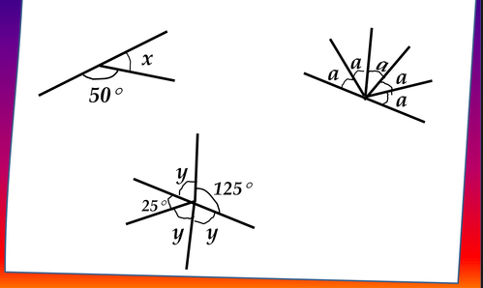

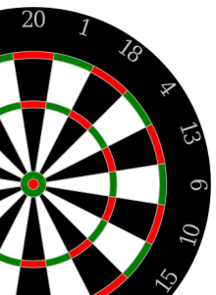

How do you find the missing angles? What properties do you need to know?

- In this ‘Z’ shape which lettered angles are the same?

- What does ‘Corresponding’ mean?
- What does ‘Alternate’ mean?
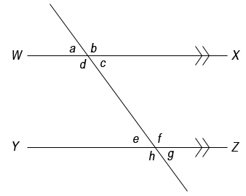

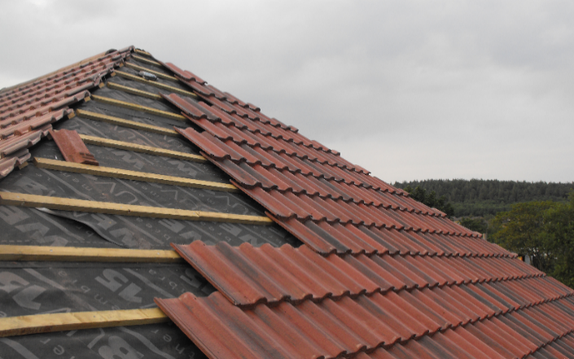

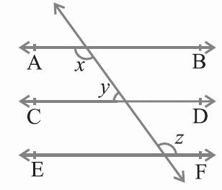
Can you write in all the angles where the ‘x’, ‘y’ and ‘z’ go

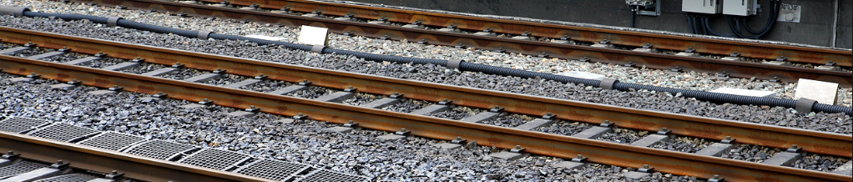

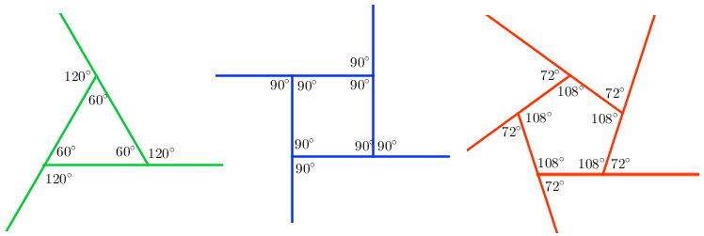

Look at the shapes and angles above.
- What can they show you about ‘exterior’ angles?
- What can they show you about ‘interior’ angles?
- Can you find a way to work out any sided shapes angles?

Discuss !

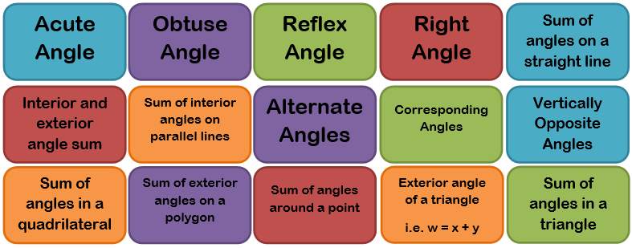

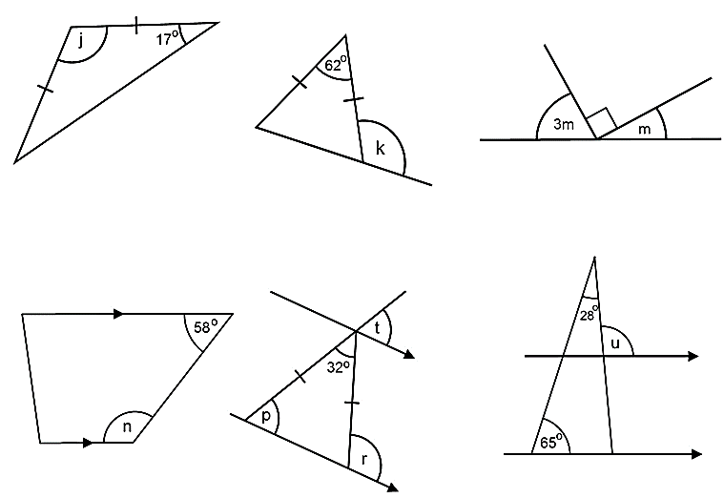
Can you label ALL the angles made in each diagram?


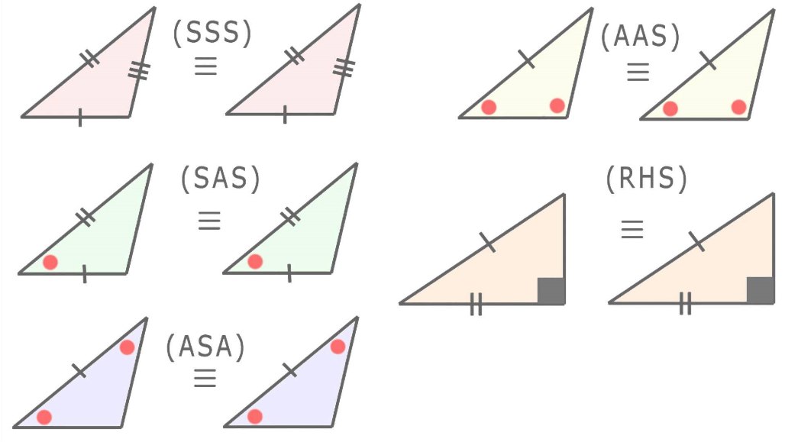

If ‘SAS’ means ‘side angle side’, … what do you think the others mean?
How is this info used to compare triangles?

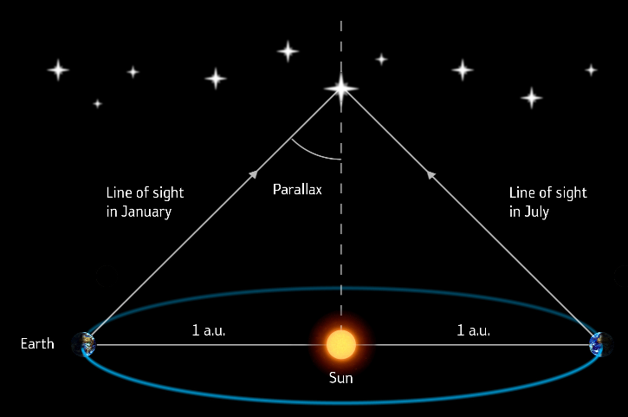
‘Parallax’ is used to measure the distance to nearby stars.
- If angle ‘x’ is 0.1 degrees, what is angle ‘y’ ?
- … and angle ‘z’ ?

y

x
z

(Higher Maths)
Using the picture could you find the distance to the object that is 0.1 degrees? What other maths is necessary to solve this?

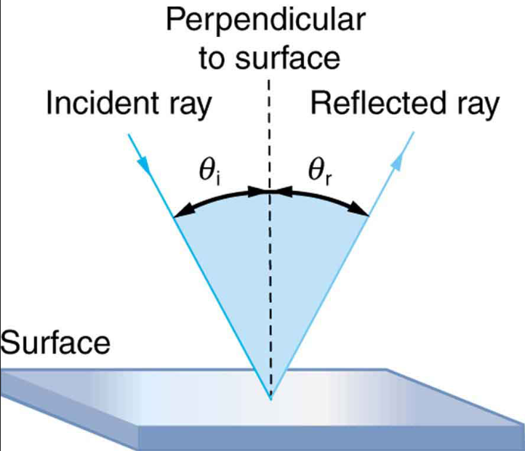
If angle ‘i’ is an equal reflection of angle ‘r’ and ‘i’ is half A… can you label with all the angle values for the 4 angles?

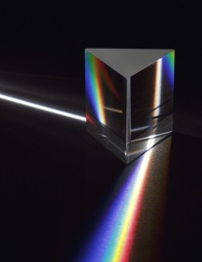

B
A

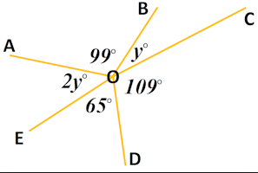
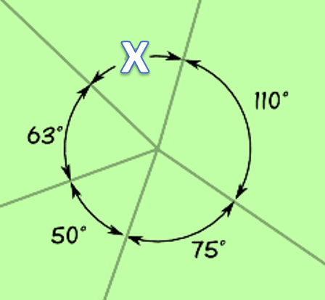

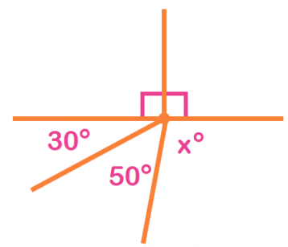

How do you find the missing angles x and y in the three diagrams?


Draw some ‘regular’ shapes. Discuss lines of reflection.
How many do each shape have?

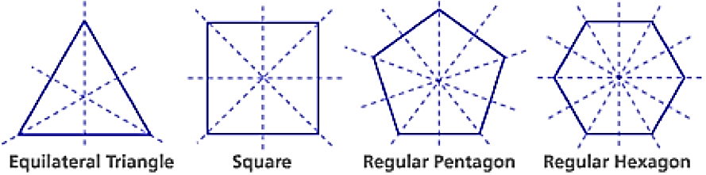

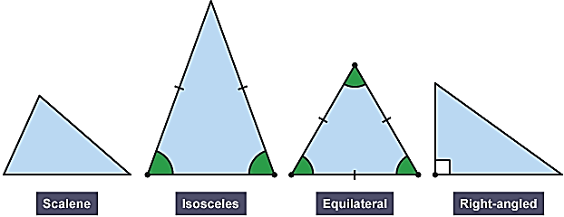
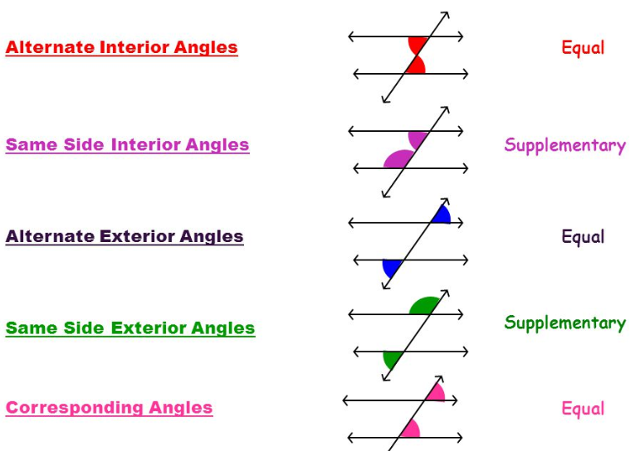
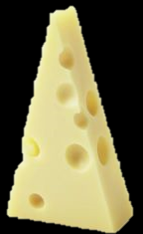
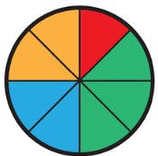
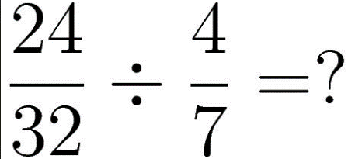
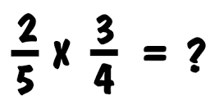
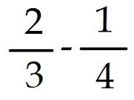
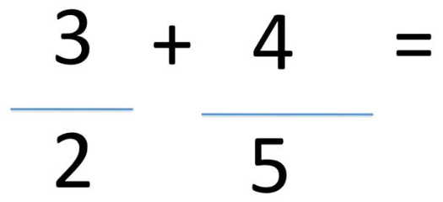

Talk over what strategies you could use to remember these terms. You will need to quote this language in your exam!!
There are 4 types of triangle. What are the properties that make each triangle different from the other?
Talk over your different methods for soving these fraction sums. How do you do them? How does someone else do them?
Is there a ‘best’ method?
out what value a fraction is as a percent or decimal?
What are fraction walls? What are they useful for? Can you write an equivalent fraction or show how you can figure

