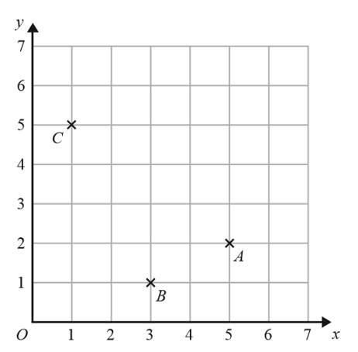

- Write down the coordinates of point C
(1)

(……….,……….)

- On the grid, mark with a cross (X) the point D so that ABCD is a rectangle.
Label this point D.
(1)

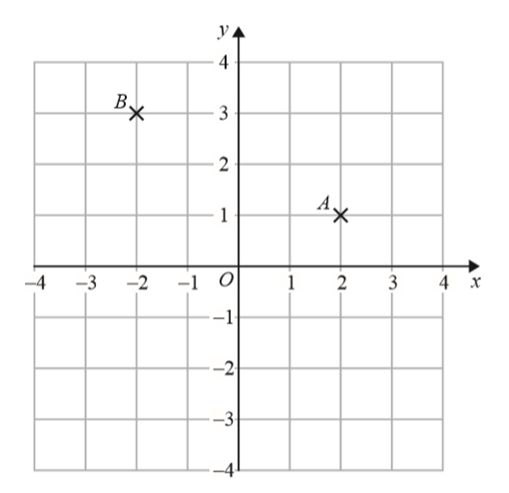

- Write down the coordinates of point A.
(1)

(……….,……….)

- Write down the coordinates of point B.
(1)

(……….,……….)

- On the grid, mark with a cross (X) the point (-3, -1)
Label this point C.
(1)

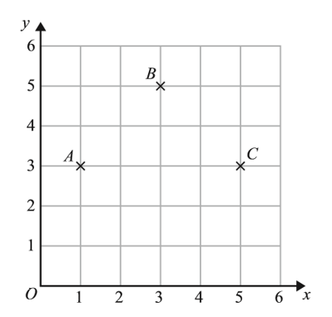

- Write down the coordinates of point C.
(1)

(……….,……….)

- Write down the coordinates of the midpoint of AB.
(1)

(……….,……….)

- On the grid, mark with a cross (X) the point D so that ABCD is a square.
Label this point D.

- Here is a triangle.
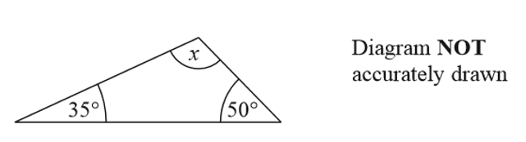

- (i) Work out the size of the angle marked $x$.
(1)

……………………………………°

(ii) Give a reason for your answer.
(1)
…………………………………………………………………………………………………………………………………………………………
…………………………………………………………………………………………………………………………………………………………
…………………………………………………………………………………………………………………………………………………………

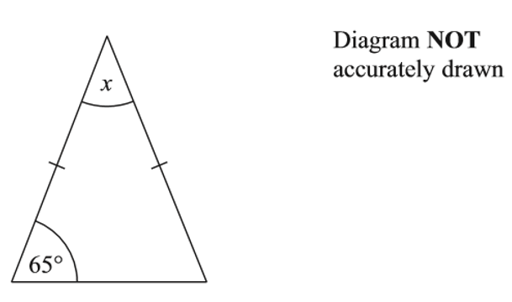

Work out the size of the angle marked $x$.
(3)

