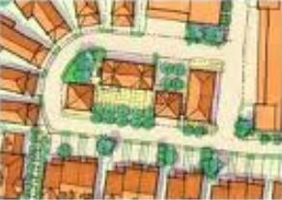
Housing
Housing
Housing
Housing

