Level 2 Functional Skills - End of Term Assessment 3

Scales, Measure, Percent and Money

- Calculate actual dimensions from scale drawings and create a scale diagram given actual measurements
- Convert between metric and imperial units of length, weight and capacity using a) a conversion factor and b) a conversion graph
- Work out percentages of amounts and express one amount as a percentage of another
- Calculate percentage change (any size increase and decrease), and original value after percentage change
- Calculate amounts of money, compound interest, percentage increases, decreases and discounts including tax and simple budgeting

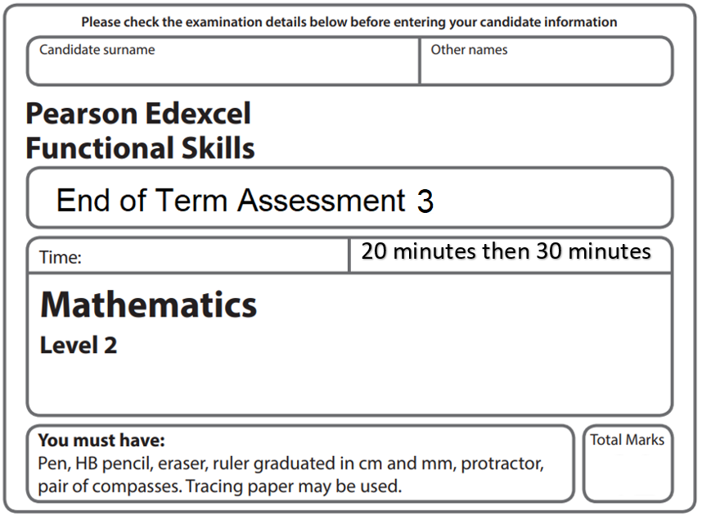
43

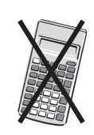
Non-Calculator Section

1) The model car is 36cm long. Use the scale and find the cars actual length in metres.
100cm = 1m (2)


1 : 5

2) a) Use the conversion graph to change 12 cm to inches. (1)
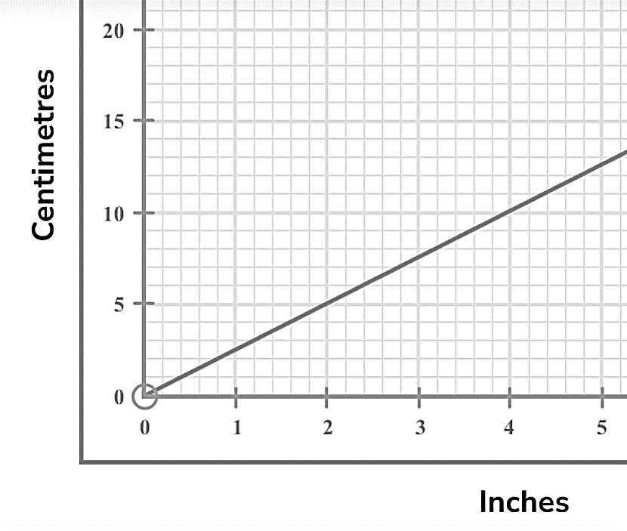

b) Use the conversion graph to change 3.2 inches to cm. (1)

3) Write £3 as a percentage of £2.50 (3)


4) Sam’s swimming practice is shown below.

Tuesday 35 laps 42mins 21sec 700m
Wednesday 30 laps 41mins 37sec 600m
Thursday 40 laps 52mins 19sec 800m

a) Sam wants to increase his laps by 5% on Friday compared to Thursday. Find his new laps for Friday. (2)

b) Sam’s distance on Tuesday is 20% higher than on Monday. Select the sum that will show Mondays distance swam in km (1)
(700 / 20) x 100 (700 / 6) x 5 (20 x 700) / 100 (700 / 1.2) / 1000
5) A house price is increases by 15% over 3 years with simple interest.
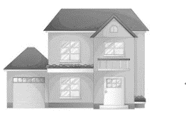
2020 £200,000
2021 ________
2022 ________

a) Find how much the house is worth for both 2021 and 2022. (3)

2021 £

2022 £

b) Find the final house price in 2022 as a percentage of 2020 (2)

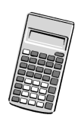
Calculator Section

1) A coastline is shown below. Find the map distance, in cm to 1dp, from town A to B if the two towns are actually 96.3miles apart. 1mile=1.67km
0
1cm
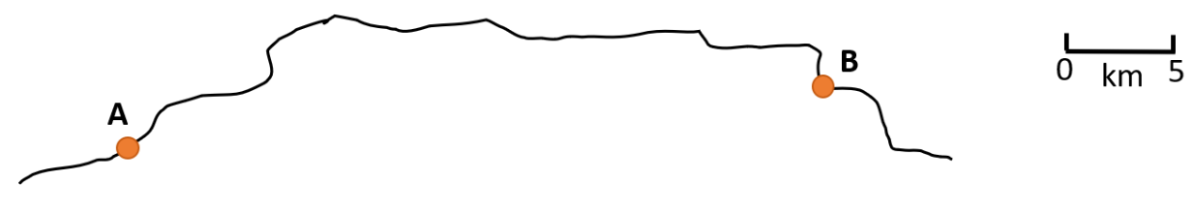

Not drawn accurately

(4)

2) A model of a famous landmark and the landmark itself are shown below. The heights of the model and the actual landmark are also shown.
Tim thinks the actual tower is over 200 times larger than his model. Show if Tim is correct.
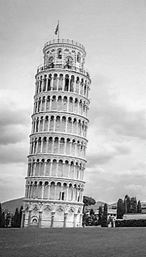
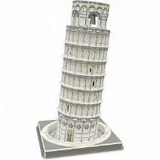
H=55.86m
H= 25.7cm

(3)

3) Janine wants to work out her budget for the month. She has the information below.
Rent £620.80
Water/gas/electric £247.60
Council Tax 20% x Rent
Food/Transport 4 weeks x £90

Wage this month £1627.19

Find her left over money after expenses as a percentage of her wage this month.

(6)

4) Convert 0.047 Litres to fl ozs using full accuracy. Do not round your final answer.

1ml = 0.0338 fl ozs

(3)

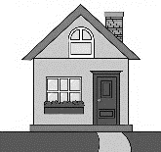
5) An Estate agent finds house price changes for their website.
A

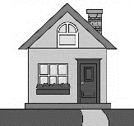
B
a) For house A Find.. 5/7 of £420,000

(2)

b) For house B Find.. 2/3 of £390,000

(2)

c) To compare these two new houses prices, the estate agent finds house A as a fraction of house B (using the prices you found in parts a) and b) ). Complete this comparison calculation and write your answer in its simplest terms using a mixed number if required.

(3)

6) Multiply 0.4328 x 1.6029 writing your answer to three decimal places.

(2)

7) Complete the sum shown using a calculator.

1 $\frac{1}{2}$ divided by 2 $\frac{2}{3}$

(1)

8) The number of fruit pickers is inversely proportional to the amount of time taken to pick fruit. A greenhouse employs 18 pickers which take 36 hours to complete a job. Find the time taken when the greenhouse employs 12 pickers.

(2)

