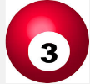
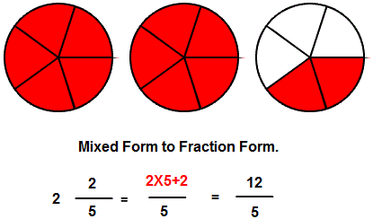


Here is two and two fifths shown in mixed and top heavy (improper) forms. Can you create some of your own examples and show each other how to change between the different forms….

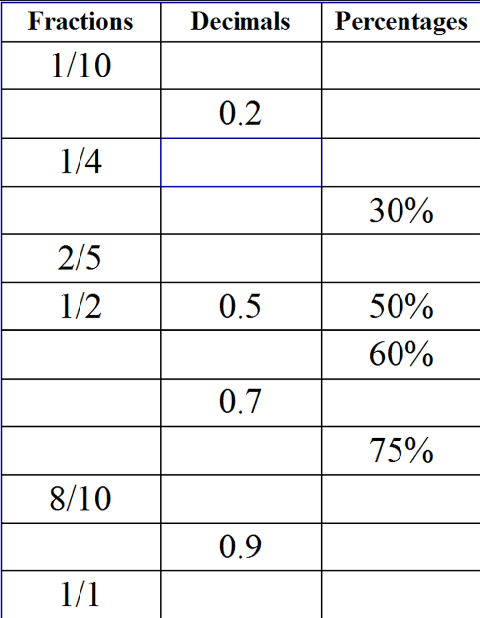
Check your basic knowledge of decimals as percentages and fractions.
Which ones do you know?
Can you fill in the blanks?
What about other values that are not on the table such as 65%, 0.47 or 1/16 ?

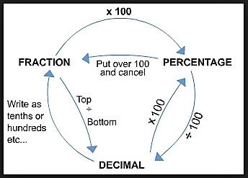
Is this a useful diagram to help you to change between decimals, fractions and percentages?
Try some of your own examples and see if they work.

Do you have different methods?
Does this method or yours always work for any dec/frac/per value?

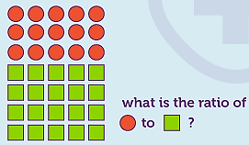
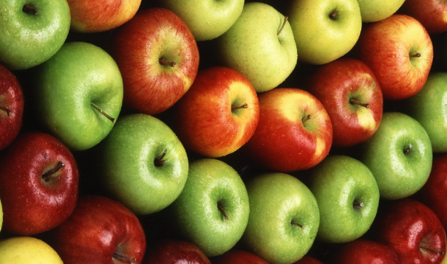

What is the ratio of red circles to green squares?
What fraction is red? What fraction is green?
What is the connection between ratios and fractions?

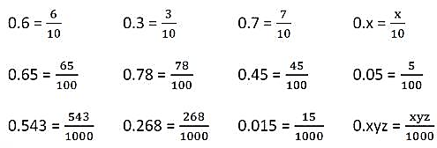

Discuss the pattern you see when changing decimals to fractions.
Could you change the fractions back to decimals?
What about 0.02076 as a fraction?
..or (0.6034)/10,000 as a decimal?

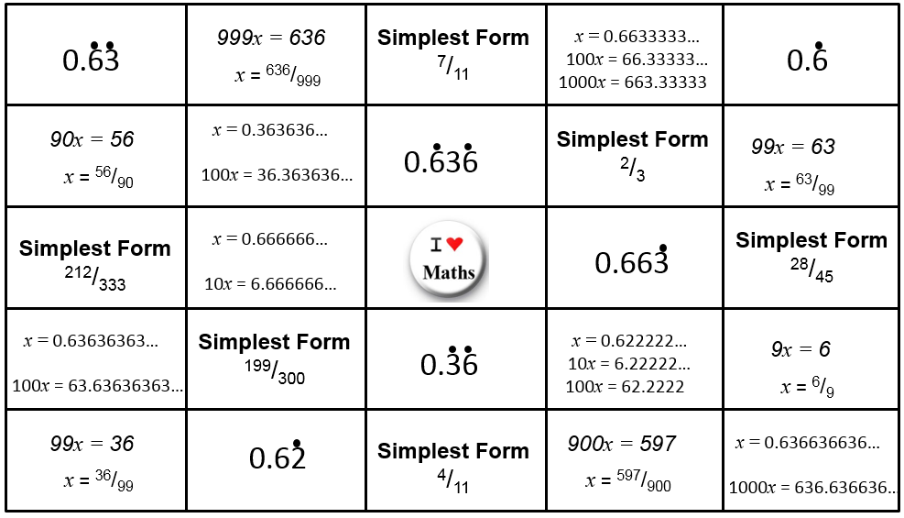

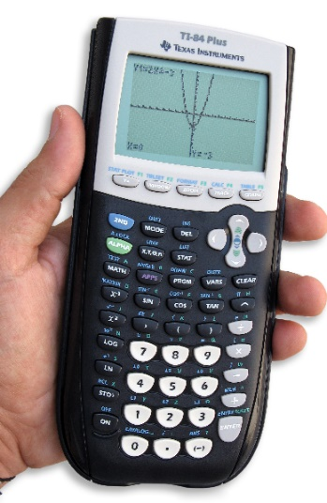
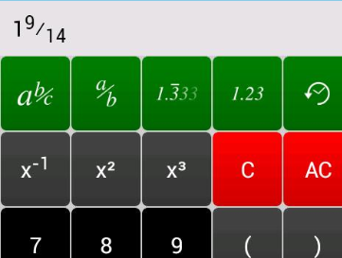

Are you happy with the buttons on your calculator when dealing with fractions? Decimals? Percentage?
Try your calculator out now…give it a go !

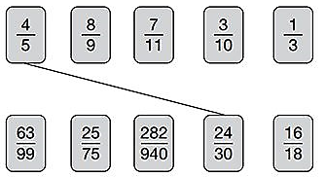
Take a fraction. Does it match to any other?
Can you write them as decimals? Percent?
Can you add or subtract one from the other?
Can you multiply two together, or divide one by the other?

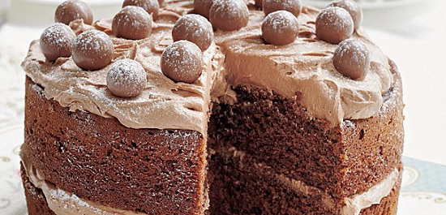

1% to 100%

Point to a number on the grid…
- what fraction of 100 is it?
- what decimal is it?
- what percent is it?
- Discuss where you would point to for 82.6%
- Where is 897/1000 ?
- Talk about where to point for 0.32859

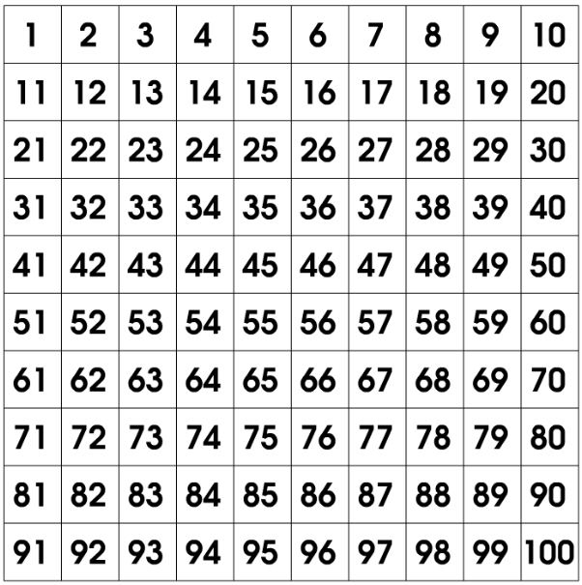

£60

£40

Two numbers are 40 and 60
Discuss how to describe 40 as a percentage of 60
What about 60 as a percentage of 40?!
If 60 is a full quantity (ie equal to 1 whole) what decimal is 40?
If 40 is a full quantity, what decimal would 60 be?
How can you write 40 as a fraction of 60?
How do you write 60 as a fraction of 40?
What is the ratio of £40 compared to £60?

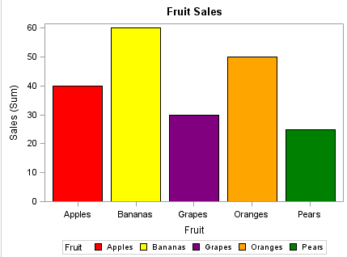
Chat about what the ratios of each fruit are compared to another.
Can you find the % of each column compared to all the fruits?
What fraction is each bar compared to another or all the fruits?

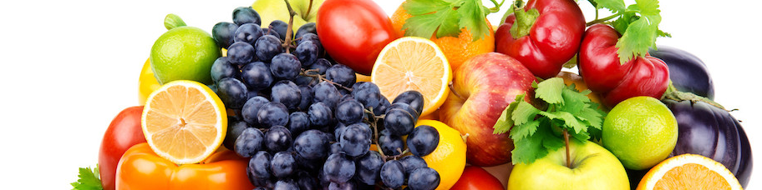

- If there were 6 blue squares how many red triangles do you need to keep proportional?
- If you add all the squares and triangles together and get 35, how many of each (squares and triangles) do you have?
- If there is only one red triangle, how many blue squares would you need to keep the proportions the same?
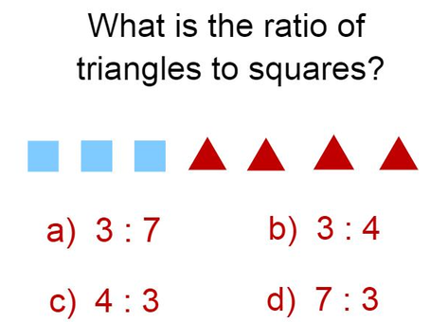

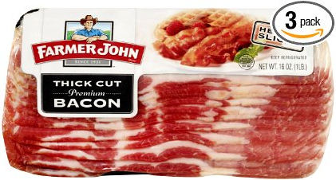
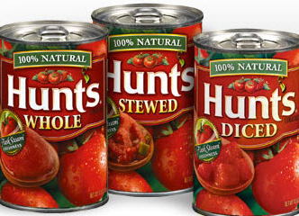
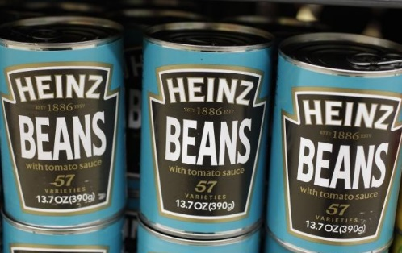

A box has 2/3 beans, 12% tomatoes and the rest is bacon.
- Can you work out how many of each item you have?
- What would you need to know to work this out?
- What are the proportions of each item to each other?

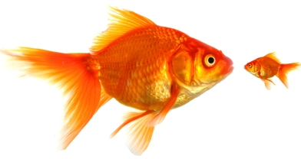

A small goldfish is 6.3 times smaller than the larger fish.
- What is the simplest ratio to compare the two fish?
- What fraction is the small fish compared to the large?
- What % of the large fish is the small one?
- The large fish is 5cm long, how long is the small?

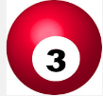
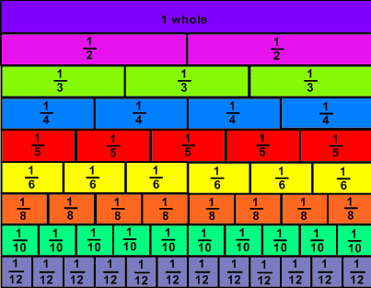

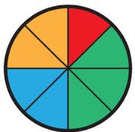
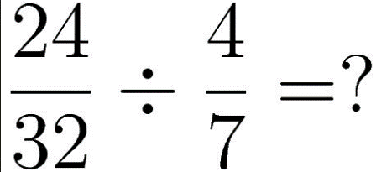
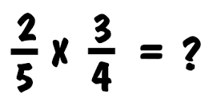
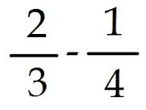
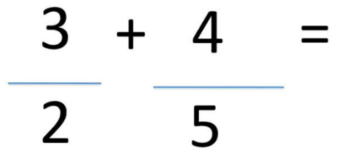
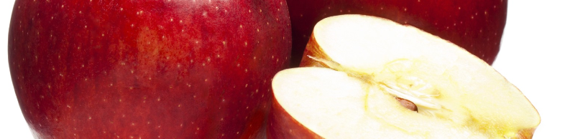
Talk over your different methods for soving these fraction sums. How do you do them? How does someone else do them?
Is there a ‘best’ method?
out what value a fraction is as a percent or decimal?
What are fraction walls? What are they useful for? Can you write an equivalent fraction or show how you can figure

