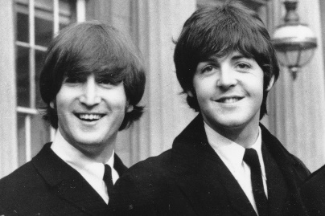

How did Pauland JOHN meet ?

Listen and answer the questions or tick the right answers
Fill in John Lennon’s memory :
‘Paul □ dated me □ the Friday I did Be Bop a Lula live on stage.
□ met me □ the final day
□ let me □ the first day
A mutual _____________ brought him to see my ______________ called the Quarry Men.
Listen to John Lennon talking about first meeting Paul Mc Cartney
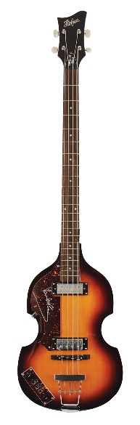
1- Paul parle d’un de ses amis, Ivan Vaughan, quel est leur point commun ? ___________________________________________________________________________
2- Pourquoi parle t-il de Ivan Vaughan ? ___________________________________________________________________________
3- Paul décrit ensuite John. Coche la description qui lui correspond le mieux
□ a guy with checked shorts, brownish hair and curls, sideboards looking pretty
□ a guy with checked T-shirt, brownish hair and curly sideboards looking pretty cool
□ a guy with checked shirt, blondish hair, curly sideboards looking pretty cool

4- Que faisait John?
□ He was playing the guitar □ He was playing the cello □ he was playing the bass guitar
5- Que pensa Paul de sa performance?
__________________________________________________________________
6- En plus de jouer de la musique John chantait. Mais quel était le problème ?
_____________________________________________________________________
7- Qu’en pensait Paul ?
_____________________________________________________________________

Listen to Paul Mc Cartney talking about first meeting John Lennon

