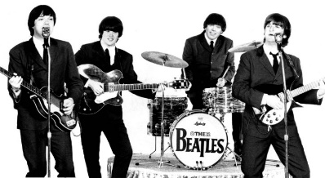
TEST : THE BEATLES
Name :______________________________
Form : ______

TRANSLATE :
1- He wanted to study = __________________________________________________
2- He wasted his time = __________________________________________________
3- His father died when he was young. = __________________________________________________
4- He grew up in Liverpool. = ______________________________________________________

THE BIOGRAPHY : Write the corresponding questions
1- ____________________________________________? I was born in Liverpool, in 1940.
2-____________________________________________? They got married in 1962.
3-____________________________________________? They had 2 children.
4- ____________________________________________? He played the guitar
5- ____________________________________________? Yes, he went to the Art College in Liverpool

CULTURE : Answer the questions
1- Name the four members of the Beatles
_____________________________________ _____________________________________

_____________________________________ _____________________________________
2- Who did John live with as a child and why?
____________________________________________________________________________________
3- Where did Paul meet John?
____________________________________________________________________________________
4- What instrument did Ringo play?
____________________________________________________________________________________
5- Give three songs by the Beatles:
______________________________ ______________________________ ______________________________
6- What was the name of the big fan movement of the Beatles? ___________________________________
7-What was the name of the Beatles’manager? _________________________________________________
8- What was the name of the Beatles’ producer ? _______________________________________________

CECRL | Capacité | Niveau de maîtrise
Réagir à l’écrit | Je peux poser une série de questions relatives à la biographie
Compétence transversale | Capacité | Niveau de maîtrise
D3 La formation de la personne et du citoyen | Maîtriser des connaissances : j'ai mémorisé les connaissances culturelles de la leçon sur les Beatles et des connaissances lexicales

