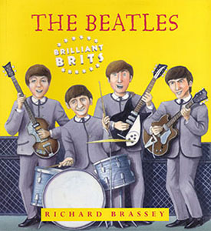

How did ringo join the Beatles ?

Now Read about how Ringo joined the group and answer the questions
1- Who was the Beatles’manager ?
…………………………..
…………………………..

2- Who was their producer?
…………………………..
…………………………..

3- Why did Ringo become the Beatles’drummer?
…………………………..
…………………………..
…………………………..
…………………………..
…………………………..
…………………………..

Brian Epstein, (then, the Beatles’ manager) worked hard to organise the Beatles, smartening them up and arranging lots of performances. Next he went to London to see the record companies. None of them thought the Beatles were good enough. Then a record producer called George Martin listened to the recordings Brian had brought ‘Very interesting’ he said.
A month later the Beatles went to London to play live for George Martin at the Abbey Road recording studios. ‘Very nice’, said George Martin – but they still had to wait another two months before he made up his mind to make a record with them. And he didn’t think Pete the drummer was good enough. When the Beatles finally went back to Abbey Road, they had a new drummer, Ringo.

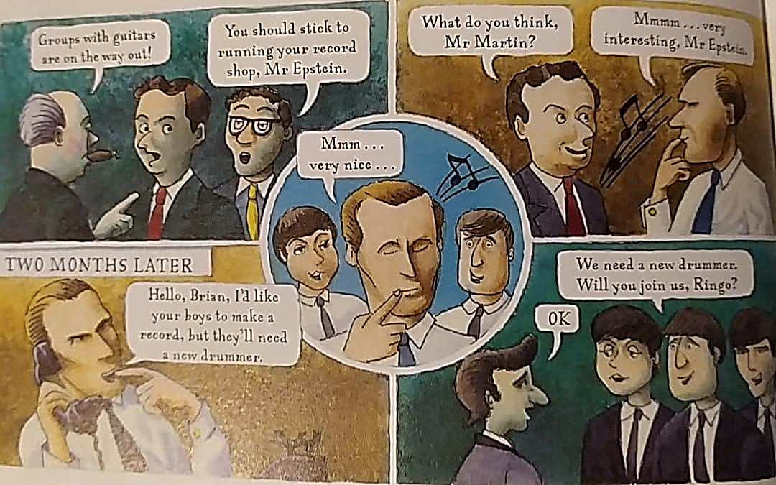
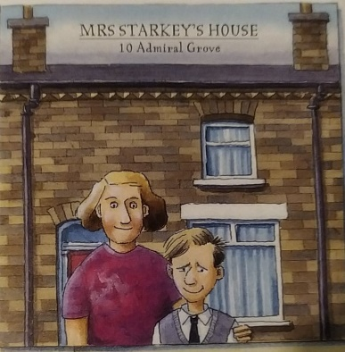
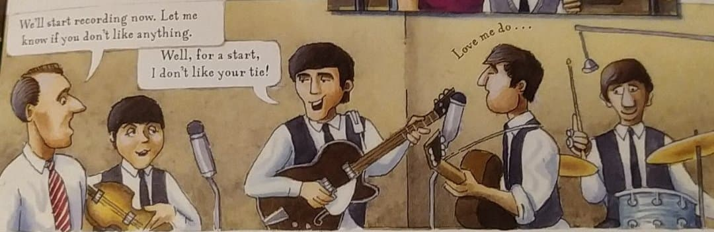
4- What do you know about Ringo’s childhood ? ………………………………………………………………………...
5- What was the Beatles’ first number one hit? ………………………………………………………………………………
P11
P12
John, Paul and George had known Ringo for a while because he was the drummer with another top Liverpool group. Ringo was brought up by his mum in a tiny house near the city centre. He’d been a sickly child and first started playing the drums in hospital. His real name was Richard Starkey, and his nickname Ringo came from all the rings he wore.

The first song George Martin recorded with the Beatles was ‘Love Me Do’, which reached number 17 in the charts. Their next song, Please, Please Me’ got to number one. […]

