
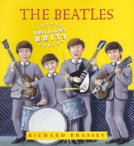
Read the document , answer the questions
P16

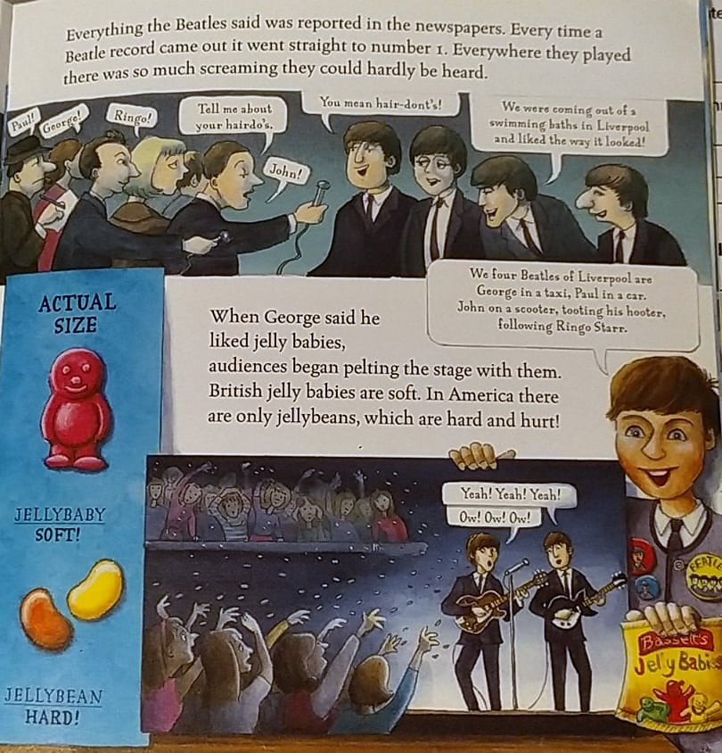

GROUP 4: p16
1- What did celebrity do to the Beatles?
1-_____________________________________________________
2- ____________________________________________________
2-Something was problematic; what was it? _________________________________________
3- What did George do or say? _________________________________________________
4- How did the fans react? ______________________________________________
5- What was the problem in America about it?
___________________________________________________________________________

