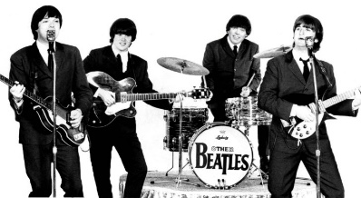
TEST : THE BEATLES
Name :______________________________
Form : ______
VOCABULARY : Translate into English
un orphelinat = difficile/dur = divorcer =
un échec = refuser =
La paix = se marier = Postuler =
L’espoir = promouvoir =

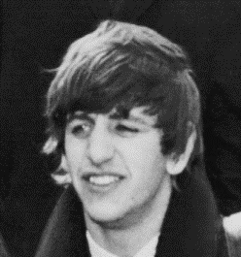
CECRL | Capacité | Niveau de maîtrise
Réagir à l'écrit | Je peux écrire un texte simple et cohérent sur un sujet familier (la biographie)
Compétence transversale | Capacité | Niveau de maîtrise
D3 La formation de la personne et du citoyen | Maîtriser des connaissances : j'ai mémorisé le vocabulaire de la leçon sur les Beatles.

WRITING : Write Ringo Starr’s biography. Use the information provided.

NAME : Richard Starkey
BORN : July 7th 1940, Liverpool
CHILDHOOD: often sick (in 1946: 6 months in hospital) , aged 13: 1 month in a Sanatorium because of a pneumonia)
MEMBER OF THE GROUP: 1962-1970
ROLE IN THE GROUP: drummer
MARRIED : Maureen Cox 1965 (divorced 1975)
Barbara Bach, 1981
CHILDREN : 3 Zak (1965), Jason (1967), Lee (1970)
ADDRESS TODAY : Monte Carlo, Los Angeles (USA)
Use the following elements to write Ringo Starr’s biography
…………………………………………………………………………..
…………………………………………………………………………..
…………………………………………………………………………..
…………………………………………………………………………..
…………………………………………………………………………..
…………………………………………………………………………..
…………………………………………………………………………..
…………………………………………………………………………..
…………………………………………………………………………..
…………………………………………………………………………..
…………………………………………………………………………..
…………………………………………………………………………..
…………………………………………………………………………..
…………………………………………………………………………..
…………………………………………………………………………..
…………………………………………………………………………..

