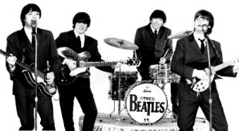
TEST : THE BEATLES
Name :______________________________
Form : ______
John Lennon is dead
LISTENING : Answer the questions
Coche la bonne réponse
1- He was shot dead □ in front of his hotel building in New York City
□ in front of his apartment building in New York City
□ in front of his uptown building in New York city
2- □ The Man who shot Lennon □ walked up to the musician (outside his Limousine)
□ The woman □ beat up the musician (outside his limousine)
3- This person shot Lennon at least □ three times □ four times □ five times □ six times
The identity of the suspect
4- name : □ Moira Davy Chapman □ Mark David Chapman □ Matt Dave Chapman
5- age: ____________ years old from: □ Miami □ Hawaï □ Crail
6- met Lennon the first time: □ this spring □ this evening at 5 □ this summer at the park
7- Lennon gave him ________________________

CECRL | Capacité | Niveau de maîtrise
Lire | Je peux comprendre des textes rédigés dans une langue courante (description d’évènements).
Ecouter | Je peux comprendre l’essentiel de nombreuses émissions de télévision si l’on parle d’une façon relativement distincte.

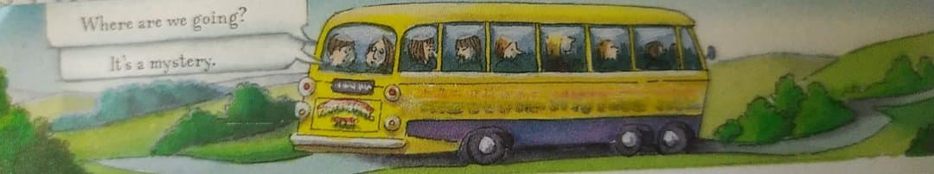
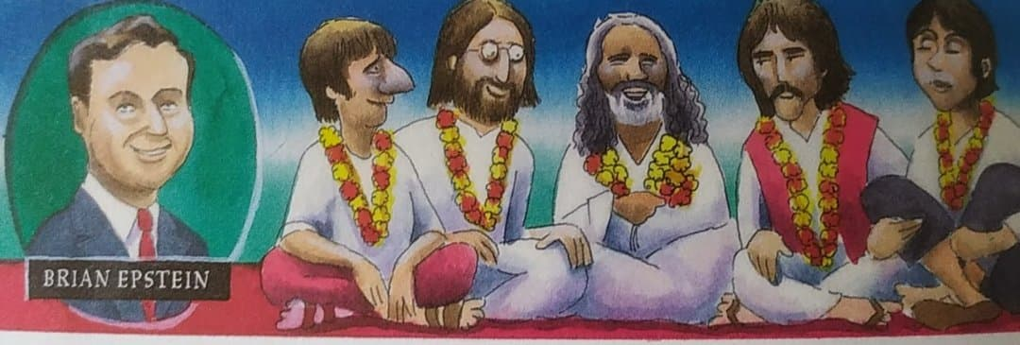
READING : Read the following text and answer the questions

That year brought another shock for the Beatles. A film they made called the Magical Mystery Tour, about them going on a bus trip with some friends, was not a success. Up to that point everybody had loved everything they did, but now Beatlemania was over. They were still hugely popular, however, and a cartoon based on Paul’s song ‘Yellow Submarine’ was a big hit.
The Beatles were drifting apart. They had all got married and were following their own interests. Even so they made two more terrific albums. The first, ‘Abbey Road’, has the famous cover which shows them on the pedestrian crossing outside the studios where they recorded all their songs. Tourists still come from all over the world to be photographed on the same spot. P21-22 The Beatles, by Richard Brassey
Orion Children’s Books

All four Beatles had begun to look for more in life than just the Beatles. An Indian guru (a teacher) known as the Maharishi taught them to spend time each day in quiet thought. They were with the Maharashi when they heard some terrible news. Brian Epstein was dead, after accidentally taking too many sleeping pills. They had relied on him to organise everything for them.

Answer the questions
1- Who did the Beatles meet in India? What did this person do?
__________________________________________________________________________________________
2-Why? Were the Beatles happy with their life? Explain.
__________________________________________________________________________________________
3- Why did Brian Epstein die?
___________________________________________________________________________________________
Tick the right answers and justify by quoting the text
4- The film the Beatles made was entitled □ The Magical Mystery Tour □Yellow Submarine □Abbey Road
‘________________________________________________________________________________________’
5-This film was □a big hit □ a failure ‘______________________________________________________’
6- Beatlemania □ was very important at the time □Beatlemania had stopped
‘________________________________________________________________________________________’
7- The Beatles all had created families □ right □ wrong
‘_______________________________________________________________________________________’
8- They didn’t make other albums □ right □ wrong
‘_______________________________________________________________________________________’

Answer the questions
1- Who did the Beatles meet in India? What did this person do?
__________________________________________________________________________________________
2-Why? Were the Beatles happy with their life? Explain.
__________________________________________________________________________________________
3- Why did Brian Epstein die?
___________________________________________________________________________________________
Tick the right answers and justify by quoting the text
4- The film the Beatles made was entitled □ The Magical Mystery Tour □Yellow Submarine □Abbey Road
‘________________________________________________________________________________________’
5-This film was □a big hit □ a failure ‘______________________________________________________’
6- Beatlemania □ was very important at the time □Beatlemania had stopped
‘________________________________________________________________________________________’
7- The Beatles all had created families □ right □ wrong
‘_______________________________________________________________________________________’
8- They didn’t make other albums □ right □ wrong
‘_______________________________________________________________________________________’

