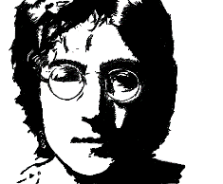

PAIRWORK : JOHN LENNON
PART 1

QUESTIONS | ANSWERS
When …………… he born ?
Where was he ………….. ? | Liverpool, England
What was ………. job ?
What was the …………of his band ? | The Beatles
…………… was his first wife?
When did they get …………….? | 1962
When ………..they get divorce?
How many children did he ………….? | 2
What are their names?
Who ………… his second wife? | Yoko Ono
When ……….. they get married?
What type of …………. did he sing? | pop
When ………. he die?
…………….. did he die? | New York City
Pose les questions pour lesquelles tu n’as pas la réponse. Ton voisin va te poser les questions grisées. Tu lui réponds.

