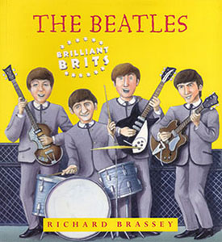

How did Pauland George join the Beatles ?

Listen and answer the questions or tick the right answers (p6 of the book)
Now Listen about how George joined the group and answer the questions (p7 of the book)
1- John’s group was first called □ the Quarrybank □ the Quarrymen □ the Quarry Band
2- In □ 1953 □ 1956 □1959, □ Paul and George came to watch.
□ George
□ Paul
3- John forgot the lyris of the song and □ invented new sentences, □ stopped singing
□ went Lalala
4- What was Paul’s reaction ? _________________________________
5- Paul was □ left-handed □ right-handed . He showed John some new chords.
6- What did he do with the guitar? __________________________________
7- How did John react? ___________________________________

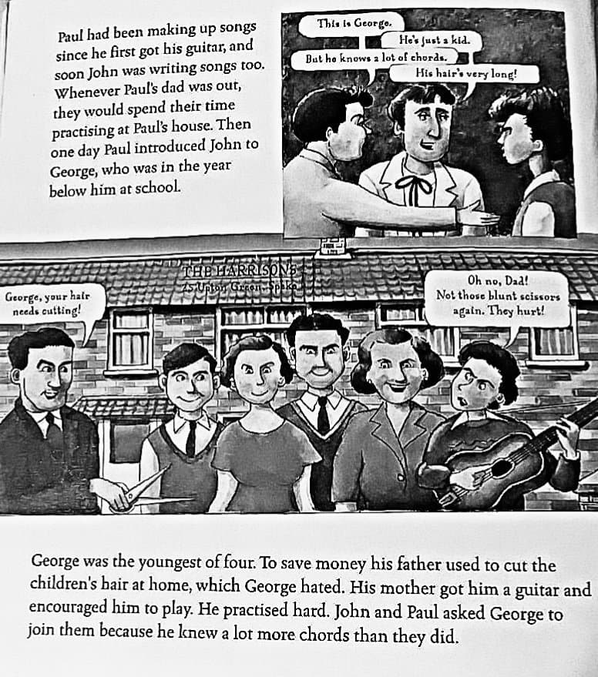
1- Who wrote the songs ?
…………………………..
…………………………..

2- How old was George when he met Paul and John ?
…………………………..
…………………………..

3- Why did Paul and John ask George to be in their group?
…………………………..
…………………………..

