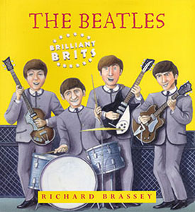

How did Pauland George join the Beatles ?

Listen and answer the questions or tick the right answers

Now Read page 7 (By Brassey) about how George joined the group and answer the questions
1- John’s group was first called □ the Quarrybank □ the Quarrymen □ the Quarry Band
2- In □ 1953 □ 1956 □1959, □ Paul and George came to watch.
□ George
□ Paul
3- John forgot the lyris of the song and □ invented new sentences, □ stopped singing
□ went Lalala
4- What was Paul’s reaction ? _________________________________
5- Paul was □ left-handed □ right-handed . He showed John some new chords.
6- What did he do with the guitar? __________________________________
7- How did John react? ___________________________________

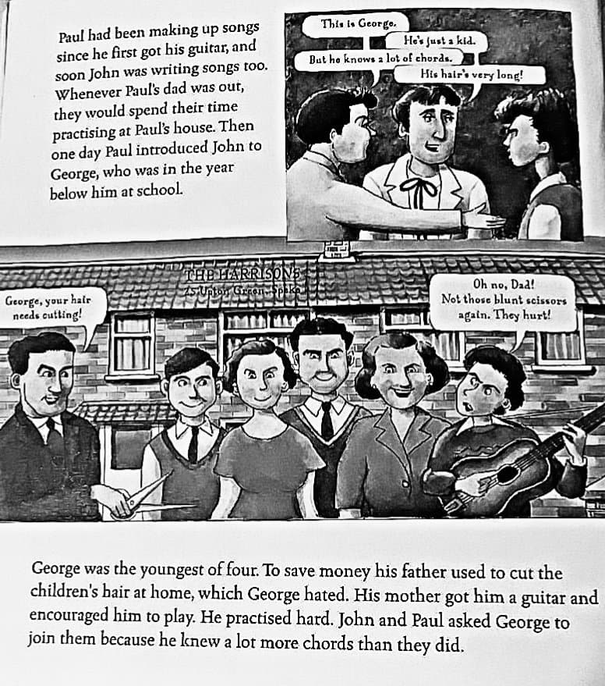
Paul had been making up songs since he first got his guitar, and soon John was writing songs too. Whenever Paul’s dad was out, they would spend their time practising at Paul’s house. Then one day Paul introduced John to George, who was in the year below him at school.
George was the youngest of four. To save money his father used to cut hair at home, which George hated. His mother got him a guitar and encouraged him to play. He practised hard. John and Paul asked George to join them because he knew a lot more chords than they did.
1- Who wrote the songs ?
…………………………..
…………………………..

2- How old was George when he met Paul and John ?
…………………………..
…………………………..

3- Why did Paul and John ask George to be in their group?
…………………………..
…………………………..

