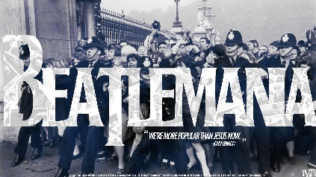
List 2 songs by the Beatles that went straight to number one:
-_____________________________________
- _____________________________________
List 1 protest song by the Beatles: - ___________________
What was special for the Beatles in these places:
1- The Royal Variety Show: ______________________________________________________________________
2- The London Airport: _________________________________________________________________________
3- The British Embassy: _________________________________________________________________________
Did the Beatles have a private life ? Explain.
____________________________________________________________________________________________
____________________________________________________________________________________________
George said he like ‘Jelly babies’, explain what happened with those sweets :
________________________________________________________________________________________
How long did Beatlemania last ? ____________________________________________
What was the ultimate consequence of it? ___________________________________________________
List 2 songs by the Beatles that went straight to number one:
-_____________________________________
- _____________________________________
List 1 protest song by the Beatles: - ___________________
What was special for the Beatles in these places:
1- The Royal Variety Show: ______________________________________________________________________
2- The London Airport: _________________________________________________________________________
3- The British Embassy: _________________________________________________________________________
Did the Beatles have a private life ? Explain.
____________________________________________________________________________________________
____________________________________________________________________________________________
George said he like ‘Jelly babies’, explain what happened with those sweets :
________________________________________________________________________________________
How long did Beatlemania last ? ____________________________________________
What was the ultimate consequence of it? ___________________________________________________

