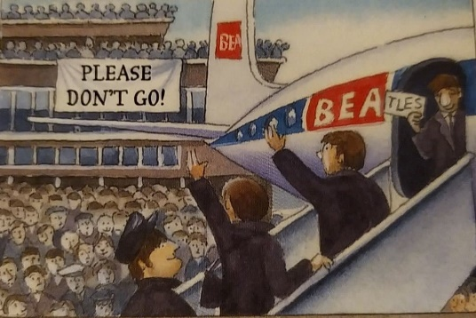
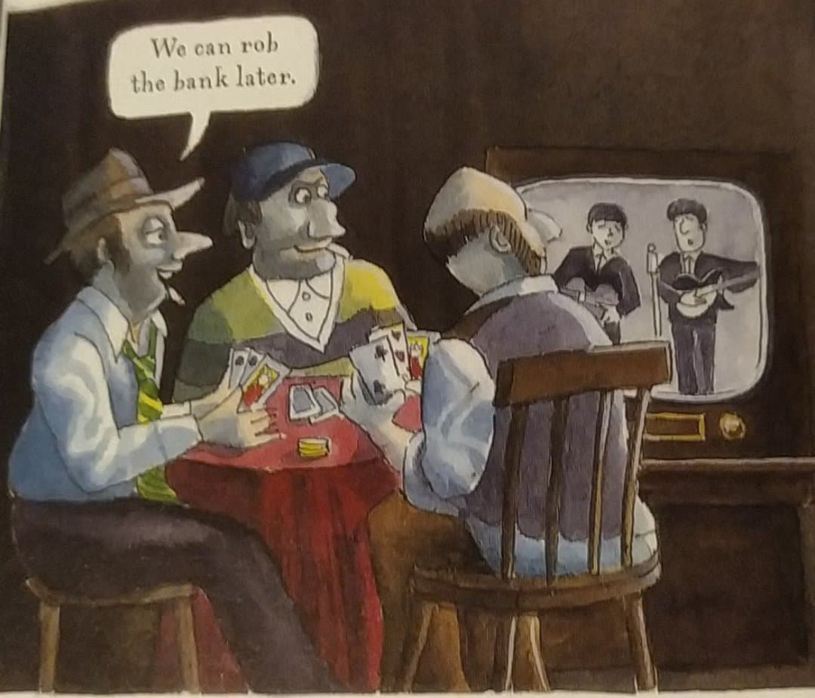
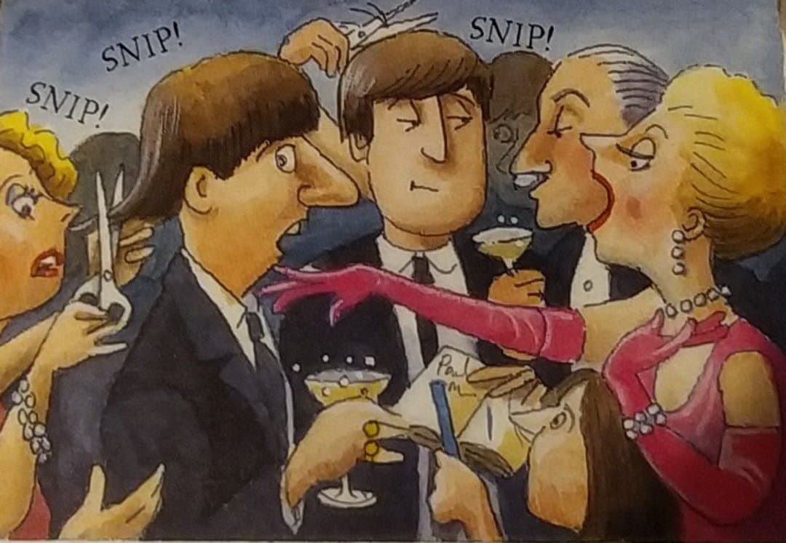
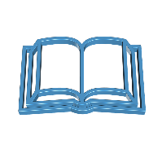
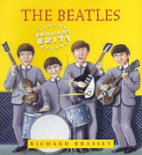
GROUP 2: p14
1- What did fans do when the Beatles announced they were going to France ? _____________________________________________________
2- How many fans were there at London airport ? __________________________________________________
3- What was ‘I want to hold your hand’? __________________________________________________
4- What was important about it? ______________________________
___________________________________________________________
5-When they went to New York what happened? a- ________________________________________________
b- _________________________________________
6- What important place did they go to in NYC? _____________________________________
7- What did people do there? ________________________________ and ______________________________
_________________________________________________
Wherever the Beatles went, huge crowds appeared. Soon people in other countries heard about them. When they went to France thousands of fans came to London Airport and begged them not to leave.
Read the document , answer the questions
After, at a party at the British Embassy, some very posh people got carried away and began fighting for autographs. Some of them even produced scissors and tried to snip pieces from the Beatles’hair as souvenirs.
When their fourth record ‘I want to Hold your Hand’ went to number one in the USA, the Beatles flew to New York to appear on the famous Ed Sullivan Show on TV. Ten thousand teenagers greeted them at the airport. Hardly any crimes took place during the show because everybody was watching, including the criminals!
P15

