
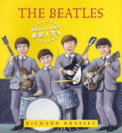
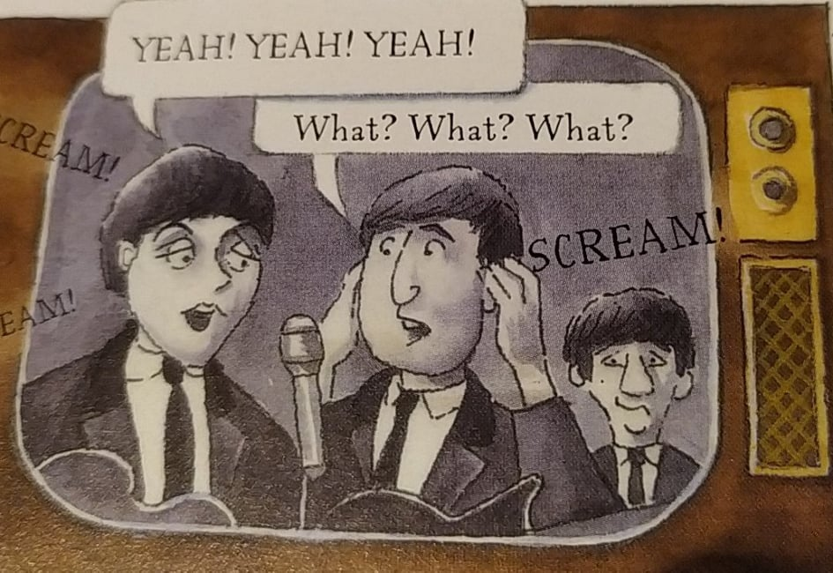
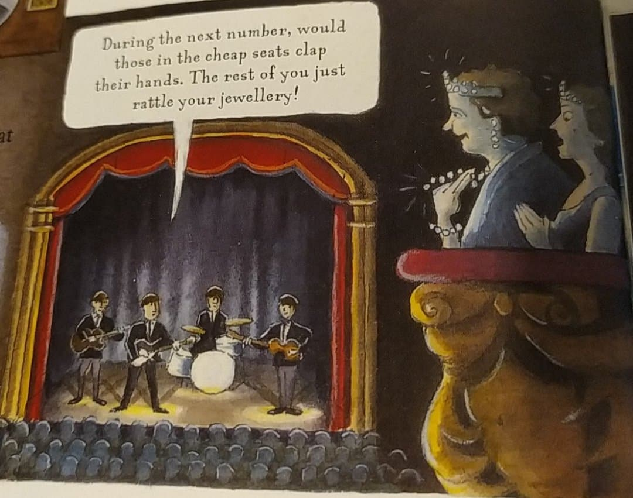
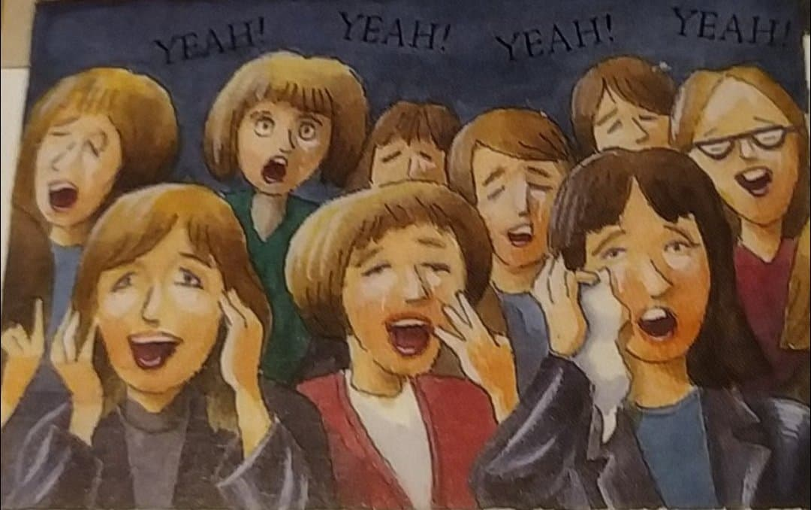
Soon there were thousands outside, screaming so loud that nobody inside could hear rehearse. Suddenly the Beatles were the biggest news in Britain. They were even asked to appear at the Royal Variety Show a few weeks later, in front of the Queen.
The Beatles’ third record, ‘She Loves You’ went straight to number one. When word got out that they were appearing on a TV show at the London palladium, fans kept arriving all day.
The show was seen on TV by a fantastic 26 million people. The world was about to experience Beatlemania. Nothing like it had ever been seen before, and nothing quite like it has been since.
P13
GROUP 1 : p13
1- What is ‘She Loves You’ ? _____________________________________________________
2- What is important about it ? ___________________________________________________
3- Why did many fans arrive to see the Beatles? __________________________________________________
4- What was the problem as rehearsing* (la repetition ) was concerned? ______________________________
___________________________________________________________
5- What very famous person wanted to see the Beatles? _________________________
6- Did she see the Beatles? _____________________ when? _______________________________________
7- What was the name of this phenomenon when many many fans desperately wanted to see the Beatles?
_____________________________________
Read the document , answer the questions

