
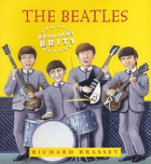
P17
Read the document , answer the questions

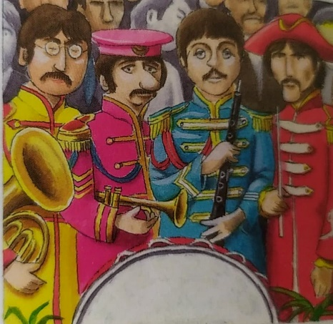
Can you imagine what it was like – never to be left alone for a minute, always in a plane, a hotel room or a huge stadium ? The Beatles felt trapped. So in 1966 they gave up performing. Instead, they went into the studio to record ‘Sergeant Pepper’s Lonely Hearts Club Band’. It was full of new sounds, such as tapes played backwards and Indian instruments. It changed pop music forever.

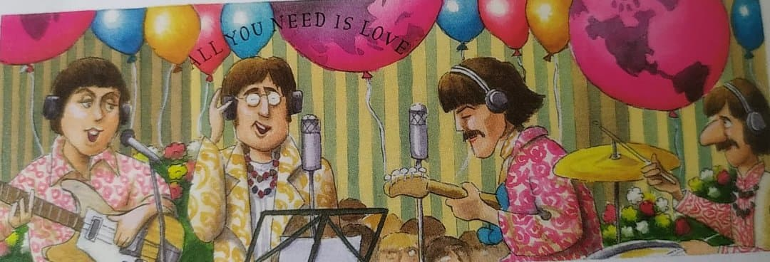
GROUP 5: p17
1- What was the Beatles’ life like? How did the Beatles live?
______________________________________________________________________________________
2-Something was problematic; what was it? _________________________________________
3- What did they do ? _________________________________________________
4- What was the name of their new album? ______________________________________________
5- What changed in their songs at the time? What message did they give?
___________________________________________________________________________
Since so many people had heard their songs, the Beatles had begun to think they should use them to say something important. When they appeared on the first TV show that linked the whole world by satellite, an audience of 400 million saw them sing ‘All You Need is Love’. At the time American soldiers were fighting in a war in Vietnam. A growing number of people thought this was wrong, and the Beatles’ message of love and peace exactly caught this mood.

