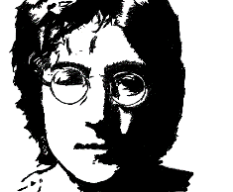

PAIRWORK : JOHN LENNON
PART 2

QUESTIONS | ANSWERS
When …………… he born ? | October 9, 1940,
Where was he ………….. ?
What was ………. job ? | Singer / songwriter
What was the …………of his band ?
…………… was his first wife? | Cynthia Powell
When did they get …………….?
When ………..they get divorce? | 1966
How many children did he ………….?
What are their names? | Julian and Sean
Who ………… his second wife?
When ……….. they get married? | 1966
What type of …………. did he sing?
When ………. he die? | December 8, 1980,
Where …….. … he die?
Pose les questions pour lesquelles tu n’as pas la réponse. Ton voisin va te poser les questions grisées. Tu lui réponds.

