
REVOLUTION
By the Beatles, 1968

I- Complete the lines. Use the words from the box

COUNT | EVOLUTION | REVOLUTION | KNOW | CHANGE | DESTRUCTION

1-You say you want a __________________
2-Well, you ________________
3-We all want to __________________ the world.
4-You tell me that it's _____________________,
5-Well, you know
6-We all want to change the world.
7-But when you talk about ______________________,
8-Don't you know that you can _________________ me out.

9-Don't you know it's going to be all right,
10-all right, all right.

II- Circle the correct word

11-You say you got a real revolution / solution
12-Well, you know / don’t
13-We'd all love to see / feel the plan.
14-You ask me / my for a contribution,
15-Well, you know
16-We all do that / what we can.

III- Put the lines in the correct order.

_____ Don't you know it's going to be all right,
_____If you want money for people with minds that hate,
_____ all right, all right.
_____All I can tell you is brother you have to wait.
IV- Match the beginning with the correct ending. Don’t pay attention to the letters in bold

21-You say you'll _____ it's the institution,
22-Well, you know _____ we all want to change your head
23-You tell me _____ change the constitution
24-Well, you know _____ make it with anyone anyhow.
25-But if you go _____ you’d better free your mind instead.
27-You ain't gonna ______ carrying pictures of chairman Mao,
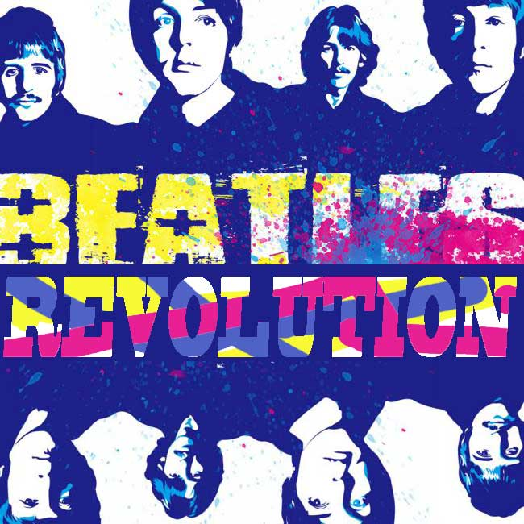
29-Don't you know it's going to be all right,
30-all right, all right.

