
DO YOU KNOW THESE HITS BY THE BEATLES?

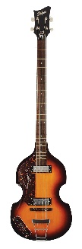
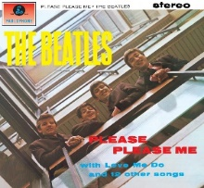
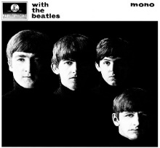
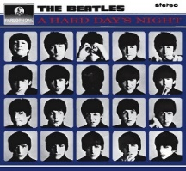
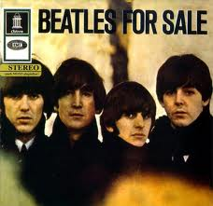
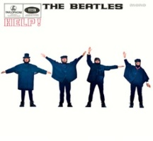
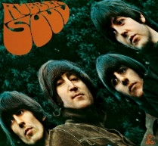

ALBUMS | SONGS | HEARD BEFORE ?
Please, Please Me. | Love, Love me do | □ YES □ NO
With the Beatles | All my Loving | □ YES □ NO
A Hard Day’s Night | A Hard Day’s night | □ YES □ NO
Beatles for Sale | Eight Days a week | □ YES □ NO
Help ! | Help !  Ticket to ride  Yesterday | □ YES □ NO  □ YES □ NO  □ YES □ NO
Rubber Soul ! | Michelle  Girl  In my life | □ YES □ NO  □ YES □ NO  □ YES □ NO
Revolver | Eleonore Rigby  Yellow submarine | □ YES □ NO  □ YES □ NO
Sergeant Pepper’s lonely Hearts Club Band | With a little help from my Friends  Lucy in the Sky with Diamonds  A Day in the Life | □ YES □ NO  □ YES □ NO  □ YES □ NO
The Beatles White Album | Ob-La-Di Ob-La-Da  Julia  Revolution | □ YES □ NO  □ YES □ NO  □ YES □ NO
Yellow Submarine | All you need is Love | □ YES □ NO
Abbey Road | Come Together  Here comes the sun | □ YES □ NO  □ YES □ NO
Let it Be | Let it be  Get back | □ YES □ NO  □ YES □ NO
