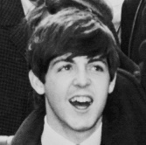
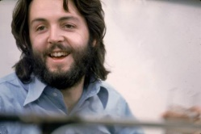
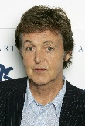
Homework : Fill in Paul Mc Cartney’s biography with the correct forms of the verbs in between brackets. Choose between the preterite or the present.
Paul Mc Cartney ______________ (BE) born in Liverpool on June 18th 1942.
He ______________ (JOIN) the group in 1960 and ______________(STAY) a member of The Beatles until 1970. He ______________(BE) a singer and the bass guitarist in the group.
In 1969, he _______________ (MARRY) an American photographer called Linda Louise Eastman. They ______________(HAVE) a very happy marriage, and Linda ______________(BE)a great help when Paul ______________(COMPOSE) songs for his new group the Wings, but unfortunately in 1998, Linda ______________(DIE) of a breast cancer.
Later, in 2002, Paul ______________ (REMARRY). The marriage to Heather Mills ______________(NOT LAST) long and they ______________ (DIVORCE) in 2008. He now ______________(LIVE) with Nancy Shevell who ______________ (BECOME) his wife in 2011.
Paul ______________ (HAVE) 5 children: 4 daughters and 1 son. He now ______________(LIVE) in Rye, England.
Paul ______________ (BE) a very active vegan*(végétarien) and he ______________ (PROMOTE= Promouvoir) the idea of meat free Monday.

Homework : Fill in Paul Mc Cartney’s biography with the correct forms of the verbs in between brackets. Choose between the preterite or the present.
Paul Mc Cartney ______________ (BE) born in Liverpool on June 18th 1942.
He ______________ (JOIN) the group in 1960 and ______________(STAY) a member of The Beatles until 1970. He ______________(BE) a singer and the bass guitarist in the group.
In 1969, he _______________ (MARRY) an American photographer called Linda Louise Eastman. They ______________(HAVE) a very happy marriage, and Linda ______________(BE)a great help when Paul ______________(COMPOSE) songs for his new group the Wings, but unfortunately in 1998, Linda ______________(DIE) of a breast cancer.
Later, in 2002, Paul ______________ (REMARRY). The marriage to Heather Mills ______________(NOT LAST) long and they ______________ (DIVORCE) in 2008. He now ______________(LIVE) with Nancy Shevell who ______________ (BECOME) his wife in 2011.
Paul ______________ (HAVE) 5 children: 4 daughters and 1 son. He now ______________(LIVE) in Rye, England.
Paul ______________ (BE) a very active vegan*(végétarien) and he ______________ (PROMOTE= Promouvoir) the idea of meat free Monday.

