L’amour et l’amitié, The love and the friendship


Don’t Think Twice It’s All Right
This song tells us the story between a boy and a girl, the boy leave his girlfriend.

La La Land
This story tells the love story between these two persons, Mia and Sebastian
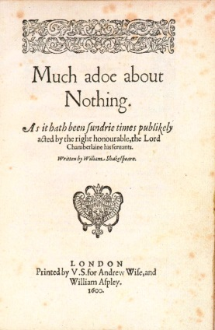
Much Ado About Nothing
This romantic comedy tells 2 couple, Claudio and Hero the romantic couple and, Benedick and Beatrice the comic couple.

She Walk In Beauty
The poet explains that combination between the inner beauty and the physical beauty gives this charm to this woman.

Annabel Lee
The narrator relate his love for a beauty woman, is a tragedy love because after the death of the woman he doesn’t stop to love her.

Jane Austen
Jane Austen was a novelist and a woman of letters, she wrote novel like Sense and Sensibility, Pride and Prejudice, Mansfield Park, and Emma.
Laurie Colwin
Laurie Colwin was a writer, she wrote novels like Another Marvellous Thingand collection of short story

