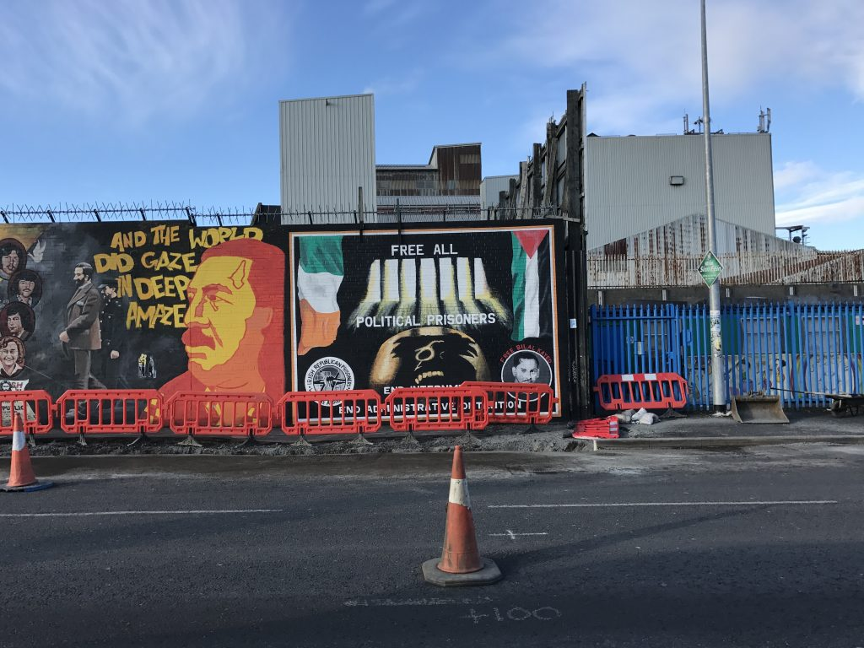
The Falls’ International Peace Wall -a big tourist draw where large works of art depict Irish nationalist movements, as well as U.S. Iraq War, the Arab-Israeli Conflict, Spanish Civil War and other global campaigns, past and present. Photo by Ivette Feliciano/PBS NewsHour Weekend
https://www.pbs.org/newshour/arts/belfast-murals-recall-brutal-war-debate-northern-irelands-future

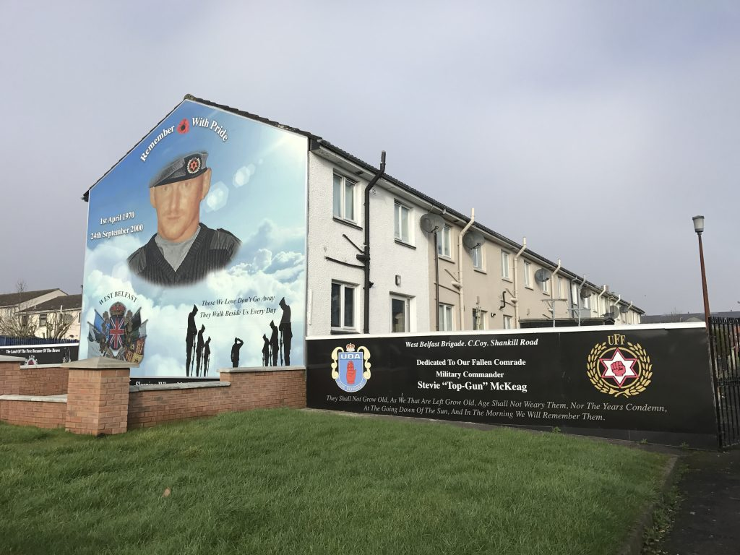
Stevie “Top Gun” McKeag, is believed to be responsible for at least 12 Catholic killings. The mural has had portions repainted to to give McKeag a more military style and muralists removed 25 ft high skeleton with a machine gun. It is flanked by crests of loyalists militias.
Photo by Ivette Feliciano/PBS NewsHour Weekend
https://www.pbs.org/newshour/arts/belfast-murals-recall-brutal-war-debate-northern-irelands-future

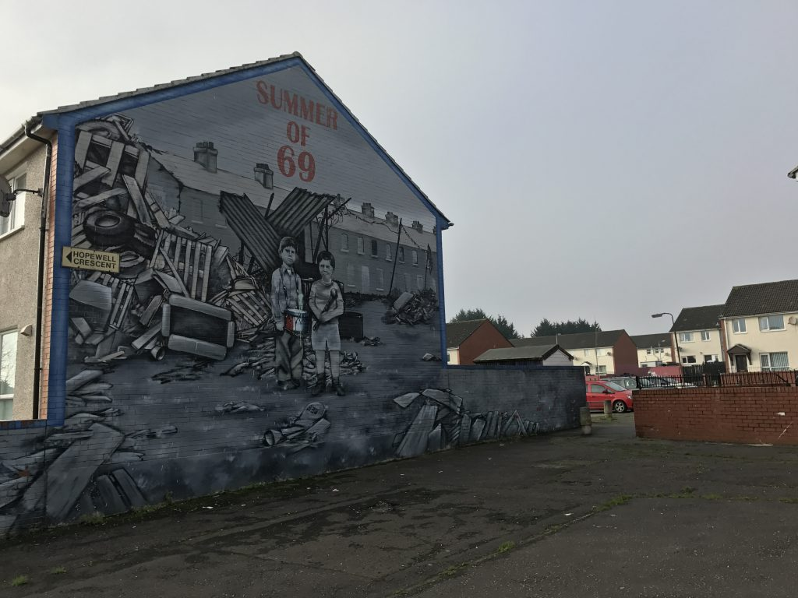
A mural in Shankill commemorates a small loyalist paramilitary group. Photo by Ivette Feliciano/PBS NewsHour Weekend
https://www.pbs.org/newshour/arts/belfast-murals-recall-brutal-war-debate-northern-irelands-future

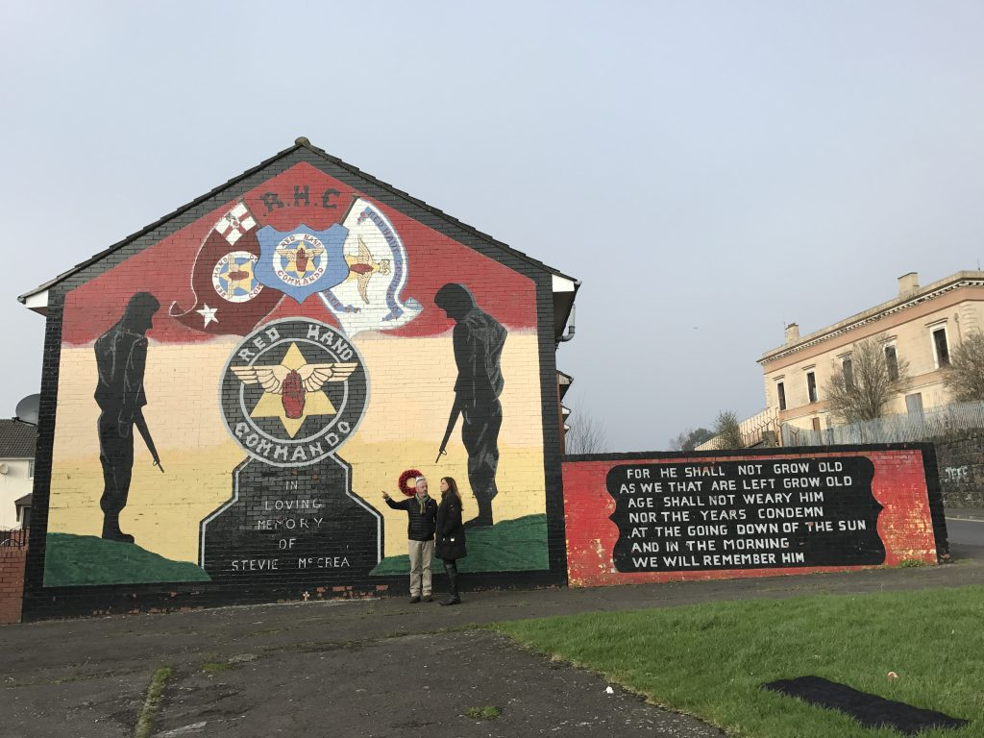
A mural recalls violence in Belfast, Northern Ireland, during the summer of 1969. Photo by Ivette Feliciano/PBS NewsHour Weekend
https://www.pbs.org/newshour/arts/belfast-murals-recall-brutal-war-debate-northern-irelands-future

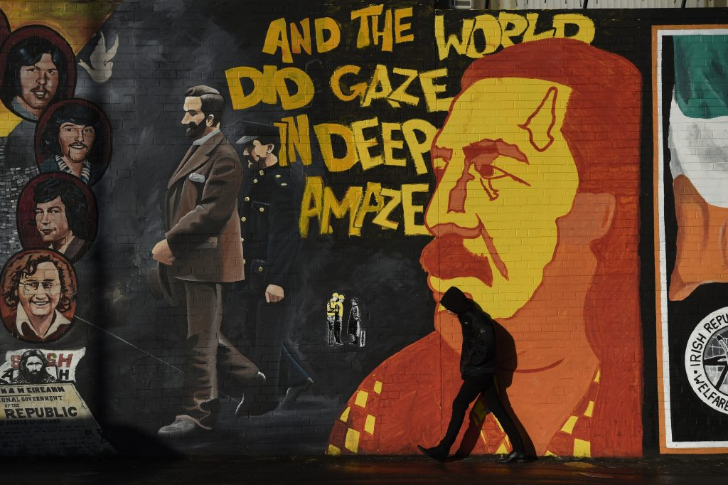
A man walks past a mural on the Falls Road in Belfast, Northern Ireland, on Jan. 10, 2017. Photo by Clodagh Kilcoyne/Reuters
https://www.pbs.org/newshour/arts/belfast-murals-recall-brutal-war-debate-northern-irelands-future

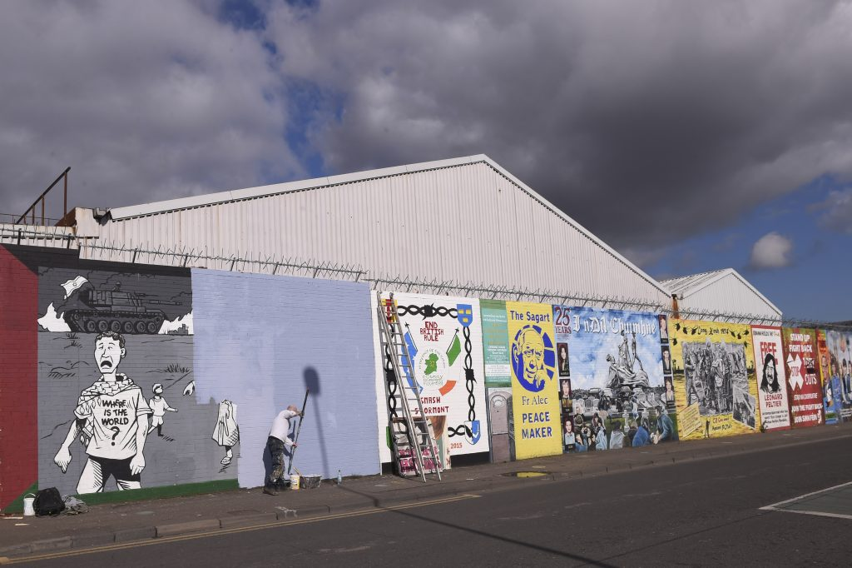
A man paints over a mural on the Falls Road, a nationalist area in Belfast, Northern Ireland, on March 10, 2016. A community cohesion strategy set up by the Northern Ireland housing executive in 2015 aims to re-image Northern Ireland over a 10-year-period, by replacing paramilitary murals and sectional symbols with images of a shared history. Photo by Clodagh Kilcoyne/Reuters
https://www.pbs.org/newshour/arts/belfast-murals-recall-brutal-war-debate-northern-irelands-future

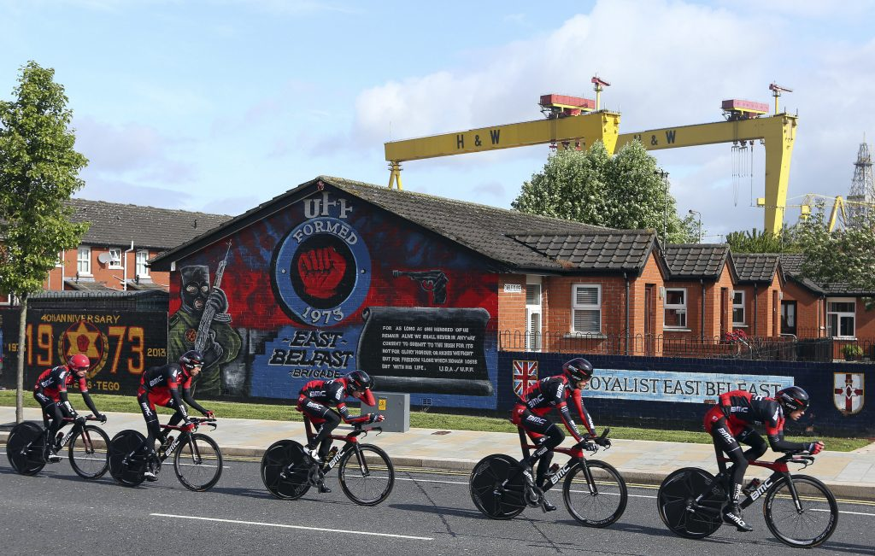
The BMC cycling team pass a loyalist paramilitary mural painted on a wall in east Belfast as they make their way around the route of the Giro d’Italia team time trial May 9, 2014. Photo by Cathal McNaughton/Reuters
https://www.pbs.org/newshour/arts/belfast-murals-recall-brutal-war-debate-northern-irelands-future

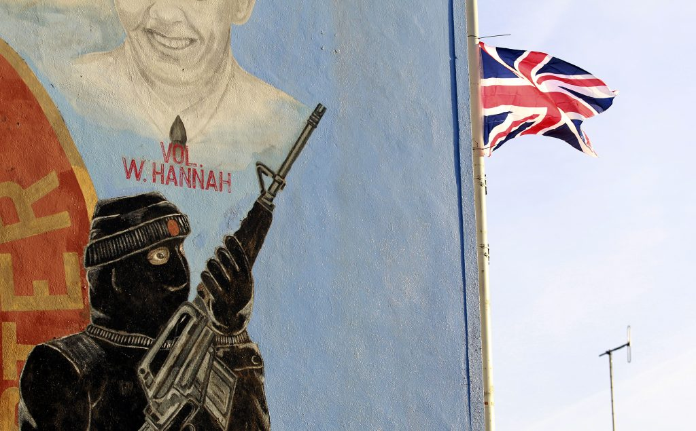
A Union flag flies on a lamp post beside a loyalist paramilitary mural on the Shankill Road area of west Belfast December 11, 2012. Police were attacked in Belfast on Monday night by loyalists enraged by a decision to remove the British flag from Belfast City Hall, which has sparked eight consecutive days of demonstrations. Photo by Cathal McNaughton/Reuters
https://www.pbs.org/newshour/arts/belfast-murals-recall-brutal-war-debate-northern-irelands-future

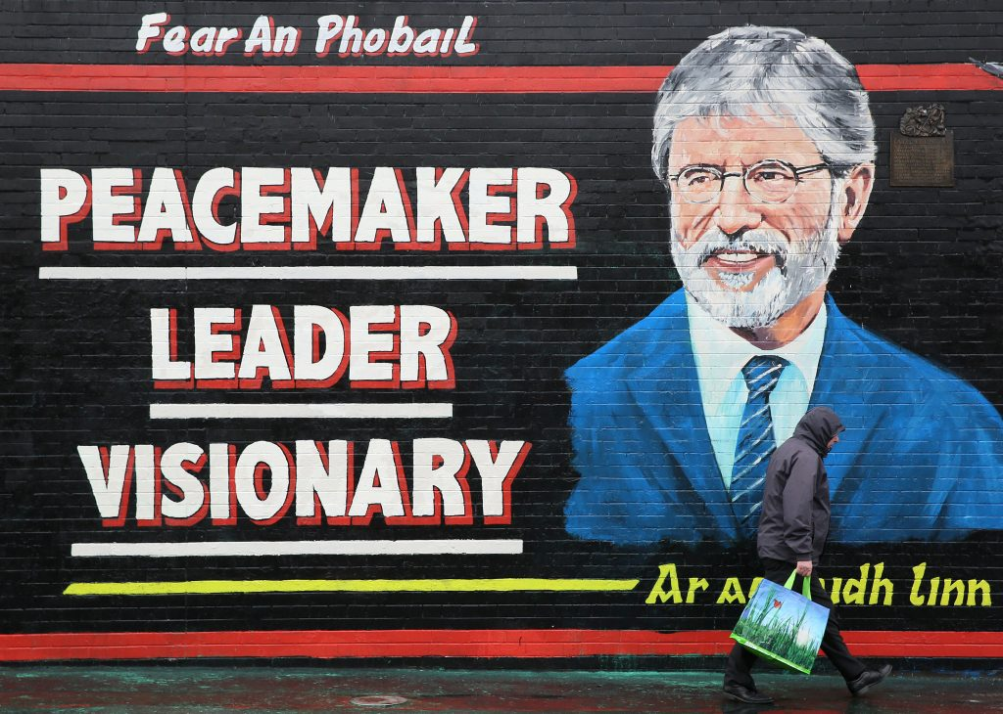
A man walks past a mural of Sinn Fein President Gerry Adams on the Falls road, Belfast May 5, 2014. Northern Ireland police released Gerry Adams from custody on Sunday and the Sinn Fein leader sought to calm fears that his four-day detention could destabilize the British province by pledging his support to the peace process. Photo by Paul Hackett/Reuters
https://www.pbs.org/newshour/arts/belfast-murals-recall-brutal-war-debate-northern-irelands-future

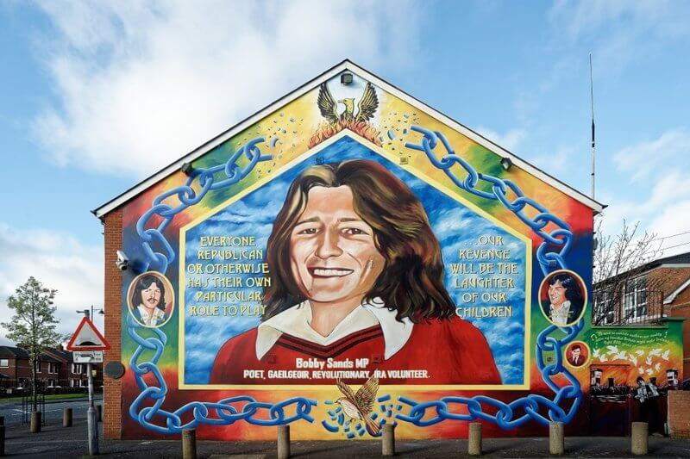

This mural in Belfast, Northern Ireland, is dedicated to Bobby Sands, a volunteer for the Provisional Irish Republican Army who became a member of the United Kingdom Parliament. He died on hunger strike while in prison. Photo by Ivette Feliciano/PBS NewsHour
https://www.pbs.org/newshour/arts/belfast-murals-recall-brutal-war-debate-northern-irelands-future

