Little Red Riding Hood

- Match the words with the pictures.

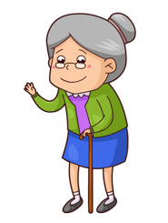  granny | 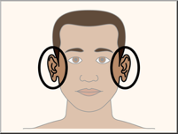  ears | 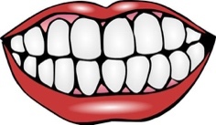  mouth | 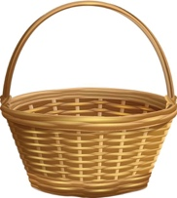  basket | 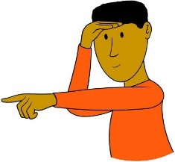  see | 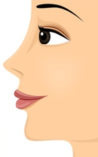  nose
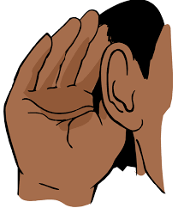  hear | 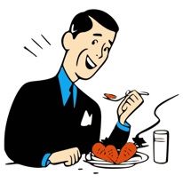  eat |   eyes | 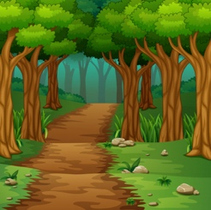  wood | 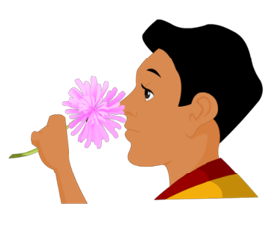  smell | 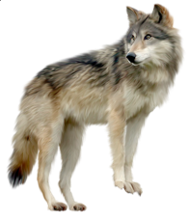  wolf

wood  /ʊ/ | granny  /æ/ /i/ | basket | wolf | eyes  /ai/ | see  /iː/
ears  /iə/ | hear  /hiə/ | nose  /əʊ/ | smell | teeth  /ˈtiːθ/ | eat  /iː/

- Listen to the story of Little Red Riding Hood and match the pictures with the right sentences.

A | On her way she met a wolf.
B | Little Red Riding Hood looked at the wolf’s eyes, ears, nose and teeth.
G | One day Little Red Riding Hood went to visit her granny.
E | Little Red Riding Hood never saw the wolf again.
C | The wolf opened his mouth wide and Granny jumped out.
F | The wolf ran to Granny’s house and ate Granny up.
D | A woodcutter heard a loud scream and ran to the house.

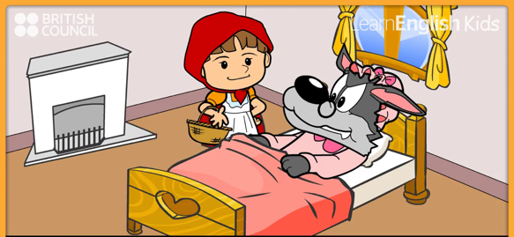
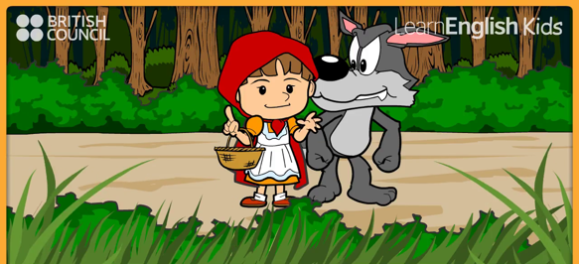
A
B

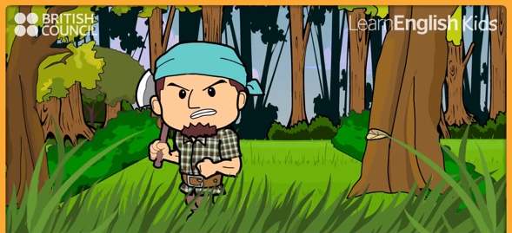

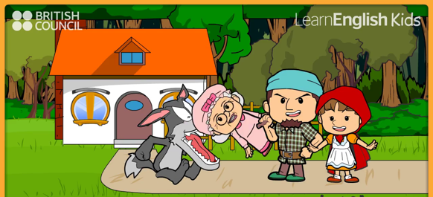

D
C

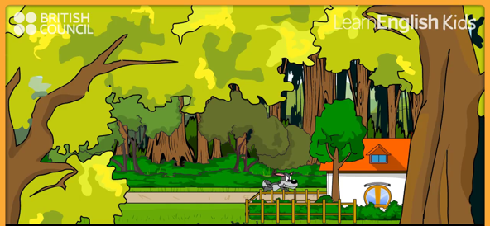
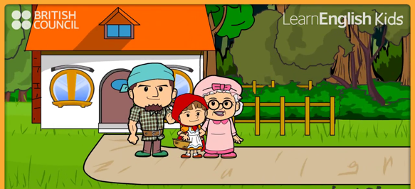

F
E

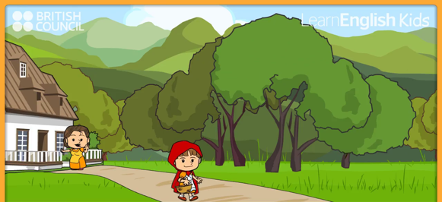

G

- Watch the story and put the sentences in order.

2 | On her way she met a wolf.
4 | Little Red Riding Hood looked at the wolf’s eyes, ears, nose and teeth.
1 | One day Little Red Riding Hood went to visit her granny.
7 | Little Red Riding Hood never saw the wolf again.
6 | The wolf opened his mouth wide and Granny jumped out.
3 | The wolf ran to Granny’s house and ate Granny up.
5 | A woodcutter heard a loud scream and ran to the house.

