Little Red Riding Hood

- Match the words with the pictures.

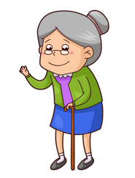  .............................. | 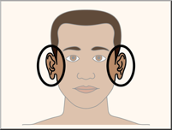  ............................ | 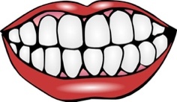  ............................ |   ............................ | 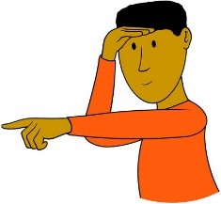  ............................ | 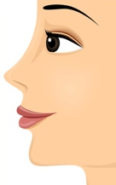  ........................
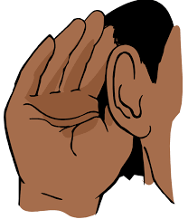  ............................. | 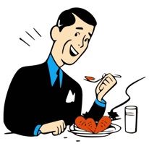  ........................ |   ........................... | 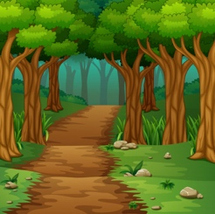  ......................... | 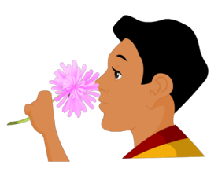  ............................ | 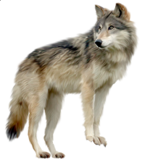  ............................

wood  /ʊ/ | granny  /æ/ /i/ | basket | wolf | eyes  /ai/ | see  /iː/
ears  /iə/ | hear  /hiə/ | nose  /əʊ/ | smell | teeth  /ˈtiːθ/ | eat  /iː/

- Listen to the story of Little Red Riding Hood and match the pictures with the right sentences.

On her way she met a wolf.
Little Red Riding Hood looked at the wolf’s eyes, ears, nose and teeth.
One day Little Red Riding Hood went to visit her granny.
Little Red Riding Hood never saw the wolf again.
The wolf opened his mouth wide and Granny jumped out.
The wolf ran to Granny’s house and ate Granny up.
A woodcutter heard a loud scream and ran to the house.

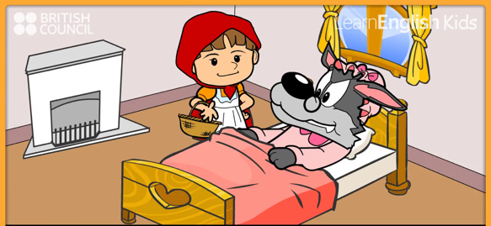
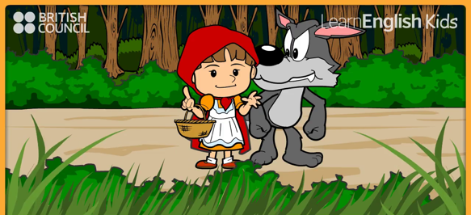
A
B

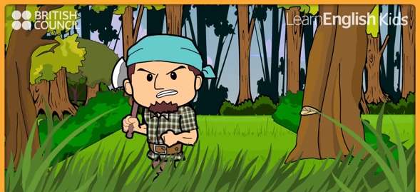

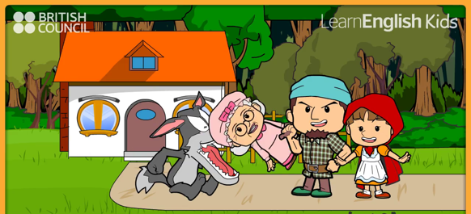

D
C

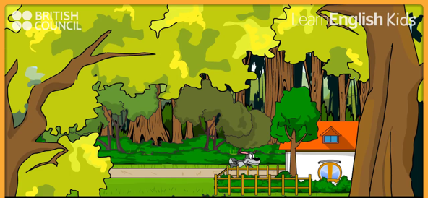
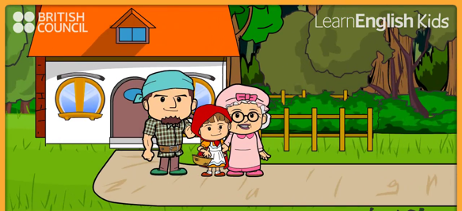

F
E

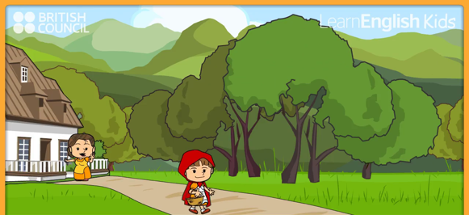

G

- Watch the story and put the sentences in order.

On her way she met a wolf.
Little Red Riding Hood looked at the wolf’s eyes, ears, nose and teeth.
One day Little Red Riding Hood went to visit her granny.
Little Red Riding Hood never saw the wolf again.
The wolf opened his mouth wide and Granny jumped out.
The wolf ran to Granny’s house and ate Granny up.
A woodcutter heard a loud scream and ran to the house.

