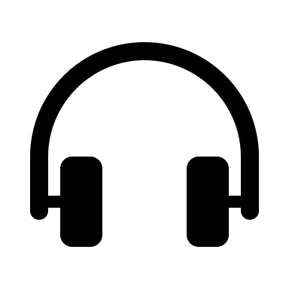
Compréhension de l’oral

Video - I bet you didn’t know : The Prohibition

MCQ : Multiple Choice Question

- What did Prohibition make illegal ?

- guns
- tobacco
- alcoholic drinks
- coffee

- The ____ Amendment started Prohibition.

- 10th
- 19th
- 20th
- 18th

- The Prohibition lasted from ____ to ____.

- 2000-2015
- 1919-1933
- 1919-1940
- 1910-1919

- True or False ? It was illegal to drink alcohol during Prohibition.

- True
- False

Justify your answer (you can use the words from the video) :

The 18th Amendment banned the manufacture, sale or distribution of alcohol, not its consumption.

- What was the slang term for the manufacturing and selling of illegal alcohol?

- Tapping
- Bootlegging
- Jogging
- Numbering

- What happened to the crime rate during Prohibition ?

- It rose
- It stayed the same
- It went down
- We don’t know

- Which president ended Prohibition ?

- George Washington
- Franklin Roosevelt
- Herbert Hoover
- John F. Kennedy

The Prohibition :

The Prohibition, or the 18th Amendment, was a constitutional ban on the production, transportation and sale of alcohol, in the United Stated from 1919 to 1933.
People didn’t stop drinking alcohol during these years but they started buying illegal alcohol from bootleggers.
Crime rates rose during prohibition and gangsters like Al Capone made a lot of money manufacturing illegal alcohol.
Franklin Roosevelt ended Prohibition in 1933.

durer
argot
augmenter
Mettre fin à

