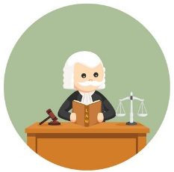
Roles in a courtroom
Match the job to its description:
Chief judge ♥ ♥Responsible for the security in the courtroom and for the safety of all participants
Prosecutor ♥ ♥ Commonly presides over trials and hearings
Public defender ♥ ♥ Perform administrative duties, assist the judge as well as the lawyers
Attorney ♥ ♥ Protect the rights of their client by offering evidence and arguments
Court clerks ♥ ♥ Presents the case in a criminal trial against an individual accused of breaking the law
Bailiff ♥ ♥ Appointed by the Superior Court to represent individuals charged with crimes

Roles in a courtroom
Match the job to its description:
Chief judge ♥ ♥Responsible for the security in the courtroom and for the safety of all participants
Prosecutor ♥ ♥ Commonly presides over trials and hearings
Public defender ♥ ♥ Perform administrative duties, assist the judge as well as the lawyers
Attorney ♥ ♥ Protect the rights of their client by offering evidence and arguments
Court clerks ♥ ♥ Presents the case in a criminal trial against an individual accused of breaking the law
Bailiff ♥ ♥ Appointed by the Superior Court to represent individuals charged with crimes

Roles in a courtroom
Match the job to its description:
Chief judge ♥ ♥Responsible for the security in the courtroom and for the safety of all participants
Prosecutor ♥ ♥ Commonly presides over trials and hearings
Public defender ♥ ♥ Perform administrative duties, assist the judge as well as the lawyers
Attorney ♥ ♥ Protect the rights of their client by offering evidence and arguments
Court clerks ♥ ♥ Presents the case in a criminal trial against an individual accused of breaking the law
Bailiff ♥ ♥ Appointed by the Superior Court to represent individuals charged with crimes

