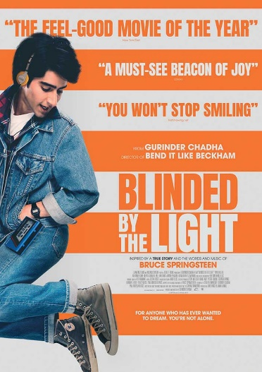
S1 DOC 2 – MUSIC IN OUR DNA

Q1- Identify the characters, the historical background, the setting…
____________________________________________________________________________
____________________________________________________________________________
____________________________________________________________________________
____________________________________________________________________________
____________________________________________________________________________
Q2- What about Javed Khan’s family background? What difficulties does the boy face?
______________________________________________________________________________________________________
______________________________________________________________________________________________________
______________________________________________________________________________________________________
Q3- Outline the influence that Bruce Springsteen’s music has on Javed’s life.
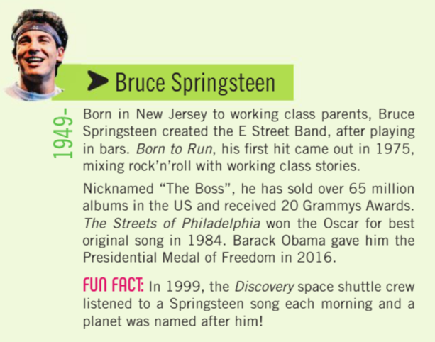
______________________________________________________________________________________________________
______________________________________________________________________________________________________
______________________________________________________________________________________________________
______________________________________________________________________________________________________

Songs in the video:
- Dancing in the Dark, Bruce Springsteen, 1984
- The Promised Land, Bruce Springsteen, 1978
- Born to Run, Bruce Springsteen, 1975

