12 ANGRY MEN – Inside the Jury Room & The First Vote
Q1- What effect does the absence of names have on the spectator?
_______________________________________________________________________________________________________________________________________________________________________________________________________________________________________________________________
Q2- What “type” of Americans do those jurors embody?
__________________________________________________________________________________________________________________________________________________________________________
Q3- Vagueness all around… listen to the scene and complete the sentences:
Juror 3: Ever hear so much ___________________________ ?
Juror 7: Yeah. What about _________________________ with the knife?
Asking grown-up people to believe ____________________________ .
- What do you conclude?
_____________________________________________________________________________________
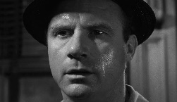
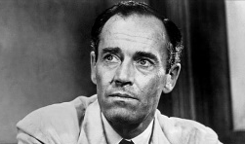
Q4- PAIR WORK (4). Choose between Juror 7 and Juror 8. Then, take notes. Compare them with your classmate (while / whereas / unlike / contrary to / in a similar way…).
 |  | JUROR 7 | JUROR 8
Movements and attitude
Speech
Clothes
Opinion
Way they are filmed

Inside the Jury Room: The First Vote…
Q1- What is the result of the first vote? How do the jurors react? Quote one of them to justify your answer.
Q2- What is the role of the foreman?
Q3- What type of shot is used to film the foreman?
Q4 – You have been assigned jurors. Compare and contrast the attitudes of the jurors.
Q5- What type of shot is used to film the group?
Q6- How is contrast rendered on camera? What does it underline?
Q7- Take a look at this scene. Comment on the behaviour of Juror 8.
Juror 2: It's hard to put into words. I just think he's guilty. I thought it was obvious from the word go. Nobody proved otherwise.
Juror 8: Nobody has to prove otherwise. The burden of proof's on the prosecution. The defendant doesn't even have to open his mouth. That's in the Constitution.
Juror 10: His window is opposite hers across the el tracks. She swore she saw him do it.
Juror 8: Through the windows of a passing El train.
Juror 8: I'd like to ask you something. You don't believe the boy. How come you believe the woman? She's one of "them" too, isn't she?

Q7- A Lesson in staging. Watch the video on the netboard (until 6:16) and take notes on what seems important to you. Here are some time codes to help you:
2:06
2:25
2:28
3:33
4:02
4:50

