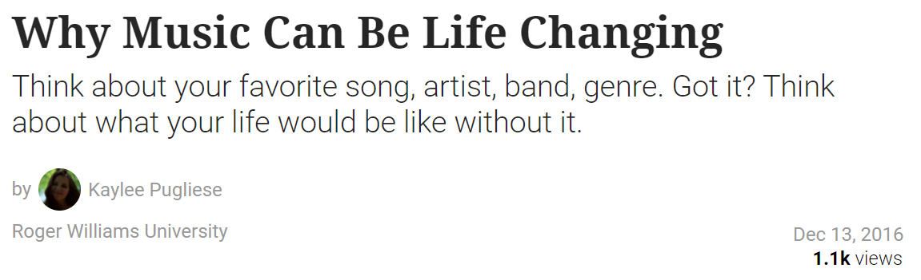
S1 DOC 1 – MUSIC IS IN OUR DNA

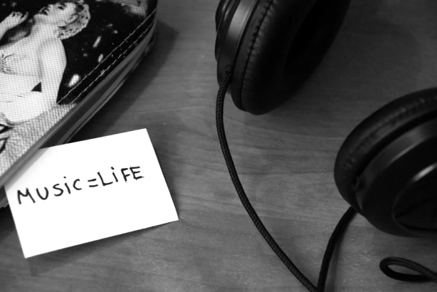
As a musician, I could not imagine life without the beauty of music. There are times when one song can completely change someone’s mood. Think about all of the bad days you may have had and then think about a song that makes you happy and how that four minutes can make your day 10 times better. That is what it is all about. In a world full of hate, anger, sadness, and bitterness, music is one thing that isn’t broken. People take all kinds of emotions and feelings and turn them into something beautiful just to make sense of all of it. They grasp at the strings in your heart that make you feel things that you cannot understand and somehow find the words to explain it all. When you cannot find the right words to say, music will speak for you. I personally take situations and emotions and put them to a melody, which is another level of satisfaction. The power of music is not only for entertainment, but it has the ability to bring people together. In times of despair, the right notes and words can make a bad situation better. An example of this is the national anthem. At sports events, political activities, and many other gatherings, this one song brings thousands of people together. Music is a symbol of unity in all situations. The national anthem joins people together in celebration of the country. Religious hymns unites people that way. Holiday songs bring people together as they go caroling through the streets. Campfire songs. The “Happy Birthday” Song. Early 2000’s classics. Those songs that make you sing at the top of your lungs with your friends driving with the windows down. People come together through the power that music has. It is almost as if the world gets put on pause for a few minutes and all of the problems and uncertainties disappear.
Music is something that you can fall in love with. It’s important to fall in love with as much as possible in this life. The truth is, love mends all. Love is the most important thing. When I fell in love with music, my life changed. Days became better, the sun seemed brighter. Music saved me and gave me something to believe in. I could feel the hope, the possibilities, and the reason to put passion and all of my heart into something. This is the case for many people. With so many artists and bands and songs out there, there are so many opportunities to find the words that you are looking for.
Moral of the story, music is beautiful. Music is life changing. It can fill the holes that you may see in your life. Music is the light that needs to be let in.
https://www.theodysseyonline.com/why-music-can-be-life-changing

