
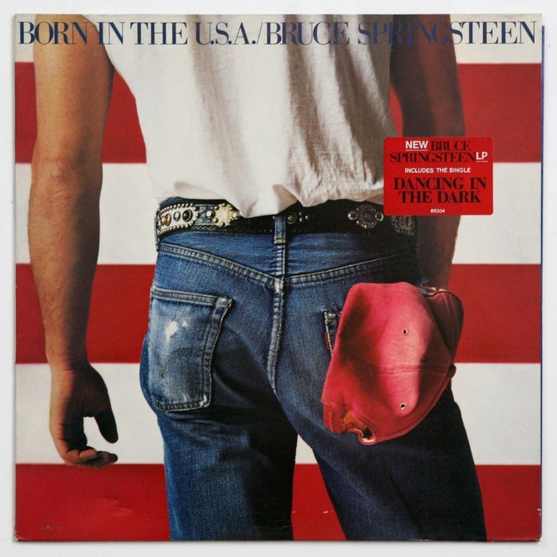
S3 DOC 1 – NATIONAL IDENTITY THROUGH MUSIC

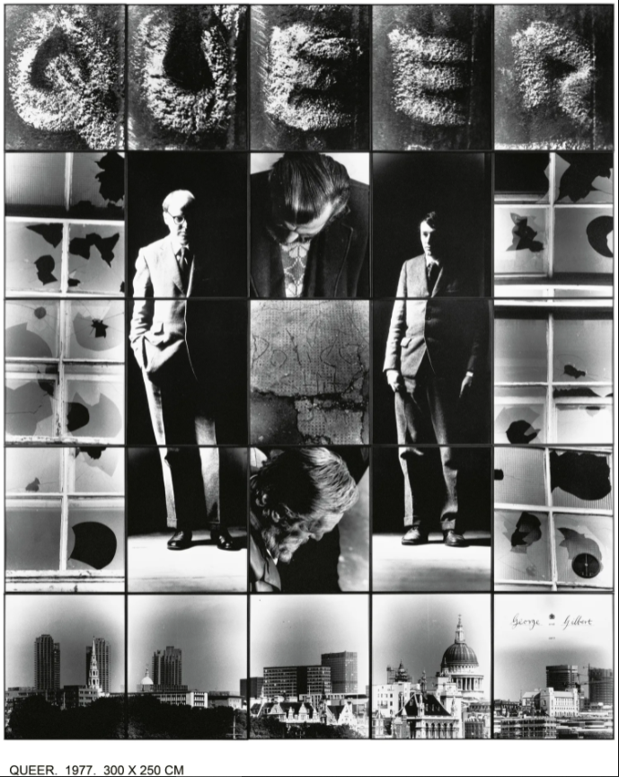
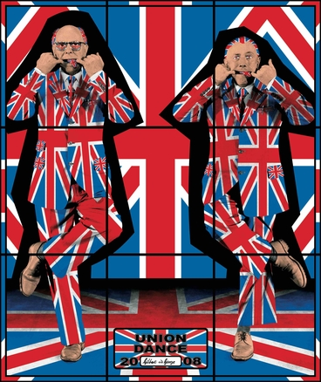
TOP: Union Dance, from the series Jack Freak Pictures, 2008
RIGHT: Queer, from the series The Dirty Words Pictures, 1977, 300 X 250 CM
Gilbert & George
Gilbert Prousch (born 1943) and George Passmore (born 1942) are two British artists who work together as the collaborative art duo Gilbert and George. They are known for their distinctive and highly formal appearance and manner in performance art, and also for their brightly coloured graphic-style photo-based artworks.

