THE JUDGE’S SPEECH
To continue, you've listened to a long and complex ________: ___________ in the first _____________.
____________________ _____________is the most serious charge tried in our _______________ _________. You've listened to the _______________, you've had the ________ read to you and interpreted as it applies in this case. It's now your __________ to sit down and try to separate the __________ from the fancy. One man is dead. Another man's life is ___ ________. If there is a _________________ ________ in your minds as to the ________ of the accused, a _____________________ _________, then you must bring me a ____________ of '____ __________'. If, however, there's no __________________ ___________, then you must, in good conscience, find the accused "_________". However you decide, your _____________ must be _______________. In the event you find the accused ______________, the bench will not entertain a recommendation for __________ . The ________ _______________ is mandatory in this case. You're faced with a grave _________________. Thank you, gentlemen.
Note: in criminal cases, the prosecution’s role is to prove to the jurors that there is no “doubt” as to the accused’s guilt, that is to say that the evidence presented can lead to no other ‘reasonable’ explanation. To reach a guilty verdict the jurors are to be convinced beyond any reasonable doubt that the defendant has committed a crime.
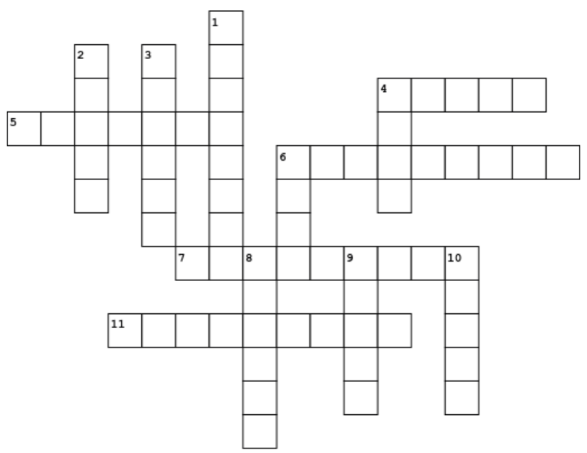
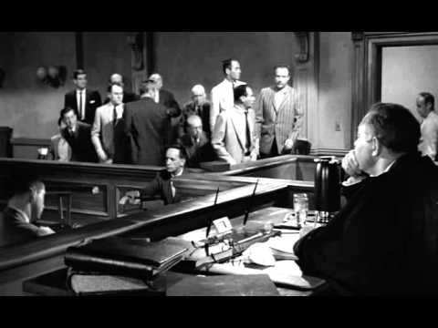

Now, complete the crossword!

DOWN
1. Judicial decision
2. Member of jury
3. Has committed a crime (adj) ACROSS
4. Group of people in charge of a verdict 4. Person in charge of judicial decision
6. Action before a judge (noun) 5. Judgement or decision
8. Not convincing (adj) 6. Place in which sessions of a law court are held
9. A feeling of uncertainty 7. Person who is accused
10. Examination of facts in a court 11. Complete agreement (adj)

