S4 DOC 2 – The British Dream
.
When I was young I used to fantasise about renouncing my British passport and moving to the United States. I was fascinated by the idea of the American Dream, the suggestion that everyone had an equal chance to make something of their lives and to be considered equally American. Bruce Springsteen seemed to be the very embodiment of that dream: someone who had been born to a working-class immigrant family and who had, through his talent and tenacity, reached the very peak of his profession. Bruce Springsteen changed my life because in his music I saw the promise of hope and escape and self-improvement, but where once I longed to
escape to the United States, these days I’m convinced my father did the right thing coming to Britain.
It has taken me three decades to realise that there is only one country which is truly mine. The life my father had built, the family he raised and the life I have fashioned are all due to living in Britain. Every opportunity, every job and every chance to pursue my dreams has been offered by this country, not by America, and not by Pakistan. My father used to tell me he regretted coming to Britain, but in truth it was the greatest gift he gave his children. I was born in Pakistan but made in England; it is Britain which is my land of hope and dreams.

Sarfraz Manzoor, Greetings from Bury Park, 2007, This passage is at the very end of the memoir
a. Who is the narrator?
b. Explain what his dream was and the reasons for his fascination.
c. “It has taken me three decades.” Comment on the use of the present perfect.

ΔWinslow Homer, Canoë in Rapids, 1897
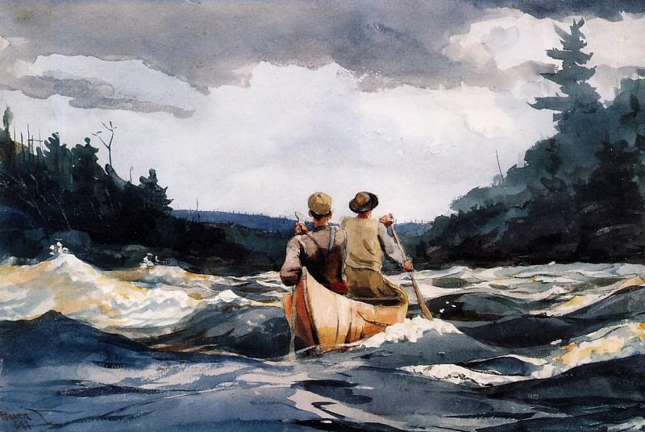
It is comforting to buy into the idea that we can ‘grow up’ into society. It suggests that there’s a place that we’re headed towards, where we might finally belong. Although the Bildungsroman’s origins are of German construction, the coming-of-age tale has become a peculiarly American phenomenon, since self-understanding in the United States is largely predicated on a self-making mythos. Where, in Britain, one might be asked about one’s parents, one’s schooling or one’s background, Americans seem less interested in a person’s past and more interested in his or her future. More cynical observers have claimed, perhaps rightly, that this is because Americans don’t have a clear history and culture; but the coming-of-age tale has also become important in the US because of a constant – maybe optimistic, maybe pig-headed – insistence that one can always remake oneself. The past is nothing; the future is everything.
This idea of inherent, Adam-and-Eve innocence, and the particularly American interest in it, is perhaps tantamount to a renunciation of history. Such denialism infuses both American stories and narratives of national identity, said Ihab Hassan, the late Arab-American literary theorist. In any case, the American tale of growing up concerns itself with creating a singular, enterprising self out of supposed nothingness: an embrace of the future and its supposedly infinite possibilities.
Cody Delistraty, Aeon (aeon.co), 8 September 2017

