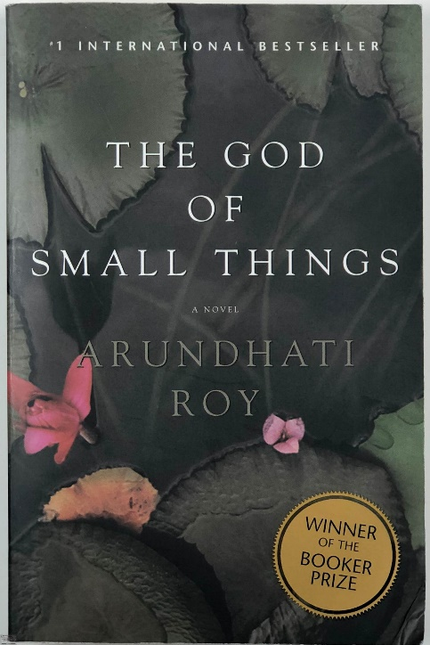
S3 DOC 2 – OUTCASTS
The God of Small Things is a novel written by Arundhati ROY in 1997. It is set in Kerala, India in the 1960s. It relates the impossible love story between Velutha, a young Untouchable, and Rahel, the daughter of his employers (Pappachi & Mammachi) who live on the other side of the river.

It was Velutha. That much Rahel was sure of. […] She knew his back. She’d been carried on it. More times than she could count. It had a light-brown birthmark, shaped like a pointed dry leaf. He said it was a Lucky Leaf; that made the Monsoons come on time. A brown leaf on a black back. An autumn leaf at night. A lucky leaf that wasn’t lucky enough.
Velutha wasn’t supposed to be a carpenter. He was called Velutha–which means White in Malayalam–because he was so black. His father, Vellya Paapen, was a Paravan. […]
As a young boy, Velutha would come with Vellya Paapen to the back entrance of the Ayemenem House to deliver the coconuts they had plucked from the trees in the compound. Pappachi would not allow Paravans into the house. Nobody would. They were not allowed to touch anything that Touchables touched. […]
In Mammachi’s time, Paravans, like other Untouchables, were not allowed to walk on public roads, not allowed to cover their upper bodies, not allowed to carry umbrellas. They had to put their hands over their mouths when they spoke, to divert their polluted breath away from those whom they addressed.
Much to his mother’s dismay, Velutha began to avoid going home. He worked late. He caught fish in the river and cooked it on an open fire. He slept outdoors, on the banks of the river. Then one day he disappeared. For four years nobody knew where he was. When he returned to Ayemenem after his years away from home, Velutha still had about him the same quickness. The sureness. And Vellya Paapen feared for him now more than ever; But this time he held his peace. He said nothing.
At least not until the Terror took hold of him. Not until he saw, night after night, a little boat being rowed across the river. Not until he saw it return at dawn. Not until he saw what his Untouchable son had touched. More than touched.
Entered.
Loved.
When the Terror took hold of him, Vellya Paapen went to Mammachi. […] One cheek glistened with tears. The other stayed dry. He shook his own head from side to side to side till Mammachi ordered him to stop. He trembled his own body like a man with malaria. Mammachi ordered him to stop it but he couldn’t, because you can’t order fear around. Not even a Paravan’s. Vellya Paapen told Mammachi what he had seen. He asked God’s forgiveness for having spawned a monster. He offered to kill his son with his own bare hands. To destroy what he had created.
Arundhati ROY, The God of Small Things, 1997

- Read the text and pick out information about the characters.
- Focus on the repetition and explain what it says about the untouchables.
- What did Velutha did and what is his father’s reaction?
- Discuss: how does this story correspond to the coming-of-age genre? What are the two main transgressions?

