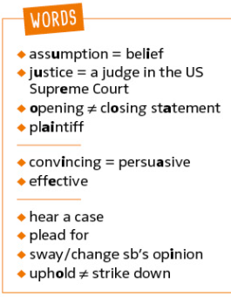
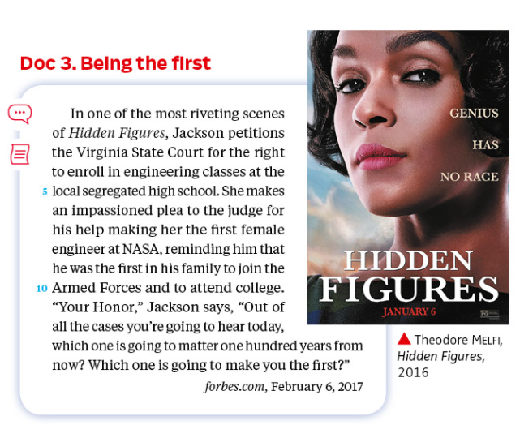
2 – Segregation in the courtroom DOC 3 – Being the First


a. What is Jackson’s main point to convince the judge?
________________________________________________________________________________________________________
________________________________________________________________________________________________________
b. What technique does she use that makes her persuasive?
________________________________________________________________________________________________________
________________________________________________________________________________________________________
________________________________________________________________________________________________________

BUILD UP YOUR PORTFOLIO
The title “Hidden Figures” has a double meaning, On one hand it refers to the mathematical calculations that went in to making John Glenn the first American man into space in 1962. On the other hand it describes Katherine G. Johnson, Dorothy Vaughan, and Mary Jackson, three African-American NASA mathematicians who did many of those calculations. “They let women do things at NASA,” says Johnson, “and it’s not because we wear skirts, it’s because we wear glasses.” […]
“Hidden Figures” details a little known but vitally important part of American history. It’s a good-hearted look at a time of great change both in the macro—American cultural shifts in the space race and in terms of race—and in the micro universe of how African American women made their mark at NASA.
Richard Crouse, iheartradio.ca, December 23rd 2016

