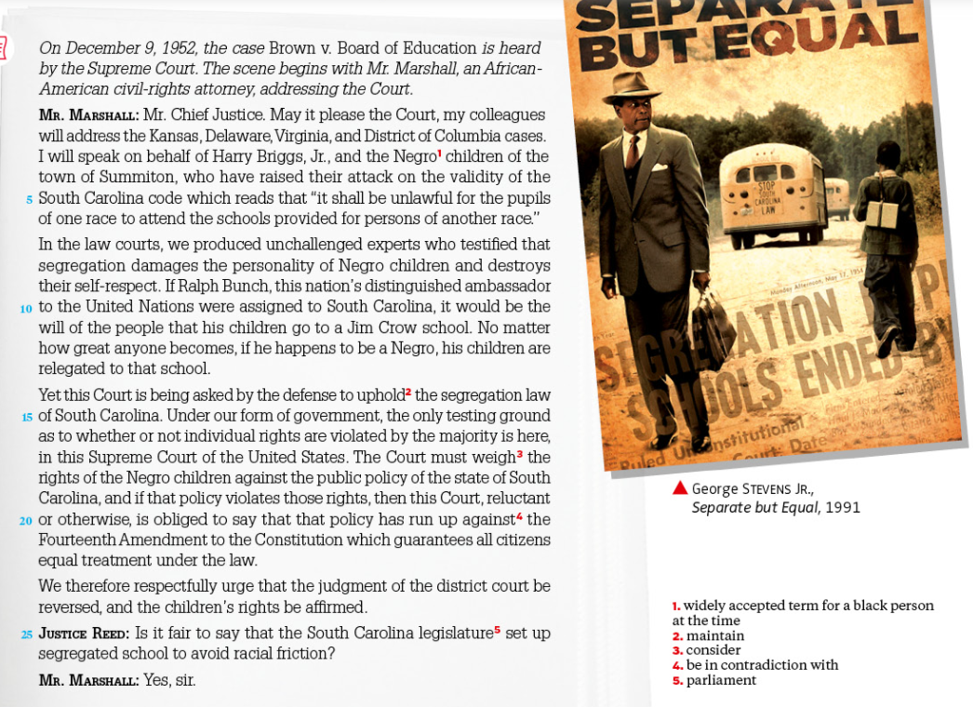
2 – Segregation in the courtroom DOC 2 – Brown v. Board of Education

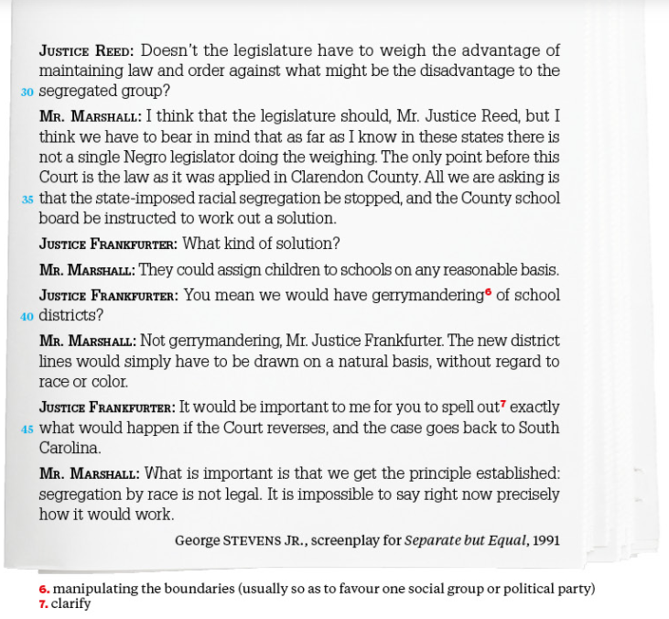
→ a. Identify the main points of Mr Marshall
→ b. Focus on the sentence l.9-11 (“If… school.”): comment on the tenses used and explain how this statement gives weight to his arguments.
→ c. Why does Justice Reed object to Mr Marshall arguments?
→ d. Comment on the way Mr Marshall responds to Justice Frankfurter’s objections.

