S4 DOC 1 BIS – Learning from Role Models
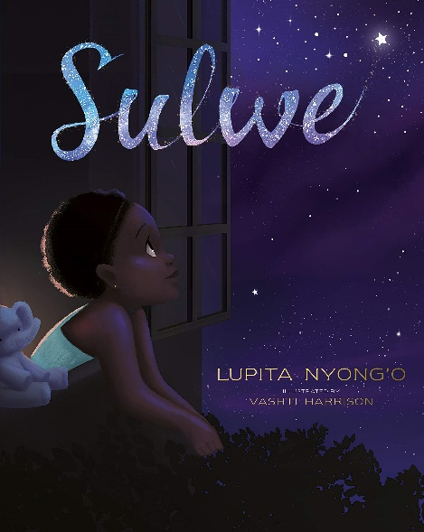
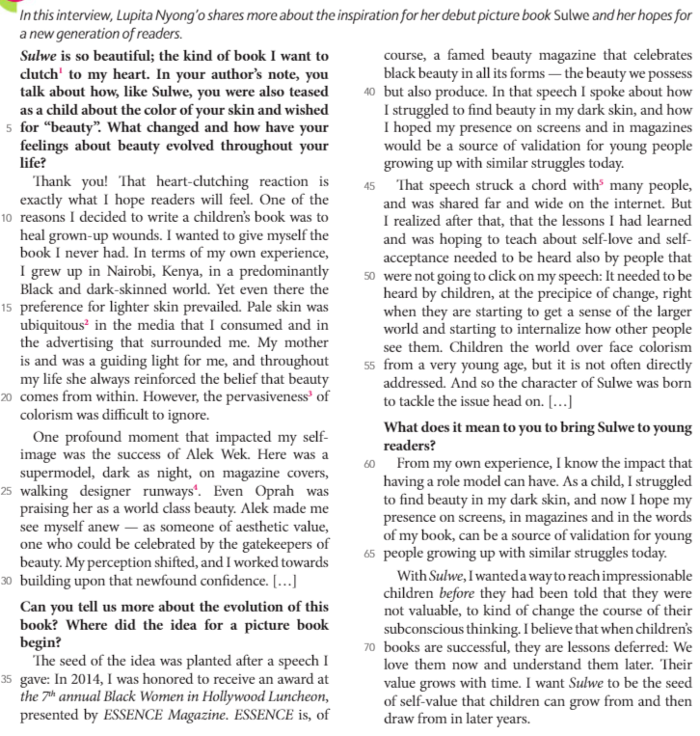
a. Explain the terms « colorism » (l.21-54), “validation” (l.43 & 64) and the expression “gatekeepers of beauty” (l.28-29).
b. Identify who Lupita Nyong’o’s role models were and say why they were important to her.
c. Pick out elements that show Lupita’s reasons for writing the book and becoming a role model herself.
TOOL BOX:
Clutch = hold tight Ubiquitous = everywhere runway = stage
Pervasiveness = omnipresence strike a chord with = provoke an emotion

