4 – Pleading for change DOC 1 – The Modern “Atticus”
1. In this true story, civil-rights defense attorney Bryan Stevenson works to free a wrongly condemned death row prisoner, Walter McMillian.
Walter McMillian was at least fifteen years older than me, not particularly well educated, and he hailed from a small rural community. Though he had lived in Monroe County his whole life, he had never heard of the author Harper Lee – also a Monroeville, Alabama, native – or her award-winning novel To Kill A Mockingbird.
Mockingbird tells the story of an innocent black man who is accused of raping a white woman in the 1930s, and is bravely defended by Atticus Finch, a white lawyer. What is often overlooked is that the black man falsely accused in the story was not successfully defended by Atticus. Tom Robinson, the wrongly accused black defendant, is found guilty. Later, he dies when, full of despair, he makes a desperate attempt to escape from prison. He is shot seventeen times in the back by his captors. While the novel captivated millions of readers, and confronted them with some of the realities of race and justice in the South, its harder truths did not take root.
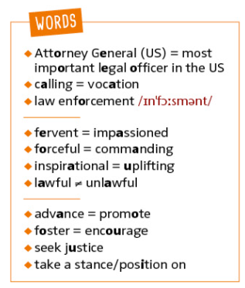
Bryan STEVENSON, Just Mercy (adapted for Young Adults), 2014
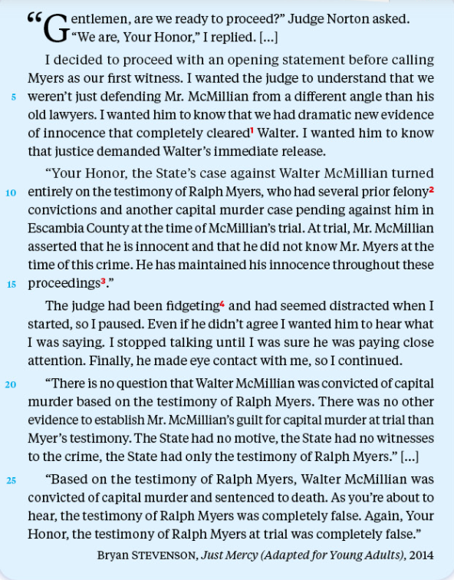

Q1. What kind of book is it?
Q2. Comment on the influence of To Kill a Mockingbird on the narrator. Can you find similarities between the stories?
Q3. Read excerpt 2 and explain what the scene depicts.
Q4. Identify the narrator’s argument.
Q5. Discuss: can Bryan Stevenson be compared to Atticus Finch?

