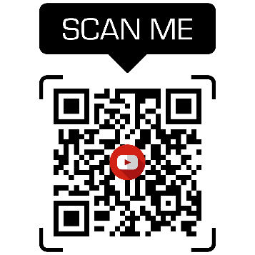
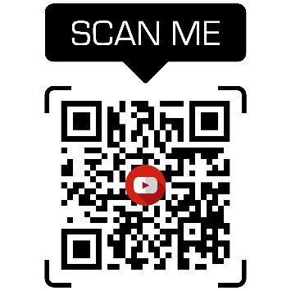
WORKSHEET CAMERA SHOT ANGLES
Listen to both videos and take notes

Type of shot | What? How? | Why?
Low angle shot | From below / we are looking up at | Make people or things look strong, powerful, awe-inspiring…
High angle shot | From above | Makes the character look weak, vulnerable, powerless
Side view | From the side (respect the axis of action!) | Seeing the scene from an observer’s point of view
Rear view | From behind / over the shoulder | Hide the character’s feelings / ignorance
Reverse shot | In one direction then roughly the opposite direction | A person and what they are looking at / two characters with close ups
Medium shot | Frame the image from the waist up | Connecting the character and the audience  Usually during conversations
Wide shot | Shows the environment | Walking talk / action scene
Extreme wide shot | Taken from a long distance | Impress the audience
Close up / frontal view | Face (below eye level / above eye level) | Conveys serious emotions / makes the audience feel engaged
Medium close up | From the torso up | Reaction / Put us at the same space as the character
Extreme close up | Shows a special feature of the face | No room for speculation
Crash zoom (niche type) | Breaks the 4th wall | Meant for laughs / alert the audience
Point of view shot | Flips the camera into the hands of the audience | How the character sees the world from their perspective
The long take | Follows a character’s movement | Shows different actions and characters at the same time

