Writing a Commentary
Methodology
A synthesis is a written commentary based on two or more sources. Your ability to write syntheses depends on your ability to infer relationships among documents. You must go beyond summary to make analyses based on your critical reading of your sources.
The purpose of an argument synthesis is for you to present your own point of view - supported, of course, by relevant facts, drawn from the documents, and presented in a logical manner. It is thus also an exercise in the close reading of a text, in the analysis and appreciation of its specificities.
For the Bac, you will have a dossier of 3 – 4 documents; you must write approximately 500 words. Most of the time, an idea of a guideline will be submitted to you: keep in mind the selected key words.
Below is a step-by-step explanation of what you should do to write a successful commentary of a dossier.

- ANALYSE THE DOCUMENTS

Here are some questions to ask yourself for each text:

1. What is the NATURE? (Literary excerpt, newspapers article, extract from a speech…)
2. What is the MAIN IDEA?
3. Does the text have any special qualities that are immediately striking? (Time and place, format, tone…)
4. What is the STRUCTURE of the passage? Is it organised in a certain way? Do you notice different main parts?
5. Does the text progress through STYLISTIC FEATURES (enumeration, interrogation, apostrophe, exclamation…)? Do you notice any peculiarities of word order? Of punctuation? Are there repetitions of words? If so, for what effect? What are the results obtained by such DEVICES as simile, metaphor, periphrasis, understatement, hyperbole, and symbolism?
6. How may the VOCABULARY be characterised? Is it abstract? Concrete? Are there allusions, proper names, archaisms, words used in special or etymological senses, incorrections, technical terms, words of local colour?
7. Does the author favour a particular kind of IMAGERY?
8. Examine the VERB TENSES chosen by the author. Do they help you understand when the action takes place (in the present, in memories, as imaginary events)?

- ESTABLISH RELATIONSHIPS AMONG THE DOCUMENTS:
- Does one document provide an example or illustration of something from another document?
- Do the documents present similar or opposing points of view on a topic? Ideas can either be opposed, complementary or reinforced. If one of your documents doesn’t fit with the other two, make something of it: argue that whereas both authors share a point of view or disagree on an issue, maybe the absence in the last document can be interpreted: why isn’t the issue tackled?
- Do the documents show that something has evolved or remained the same over time (decades or even centuries)?
- How do the nature and source of each document affect our understanding of it?
- Were the documents written for the same audience?
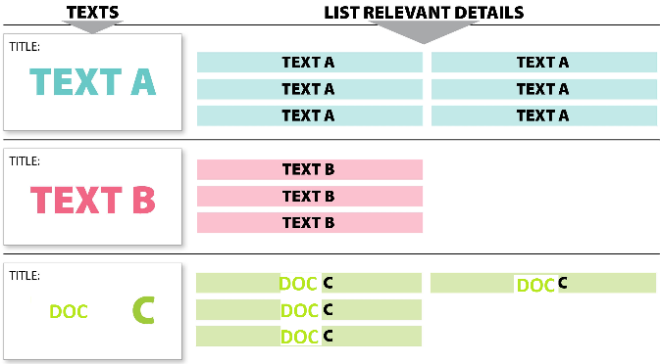
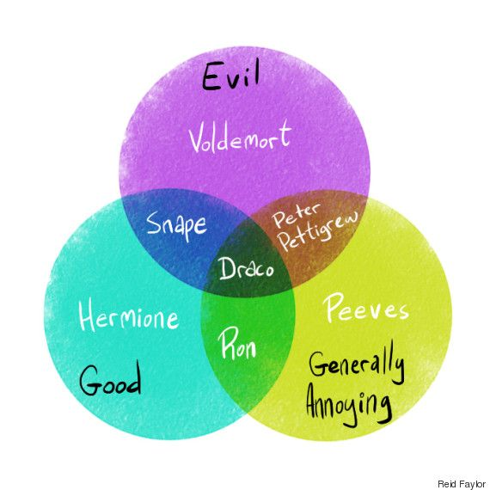
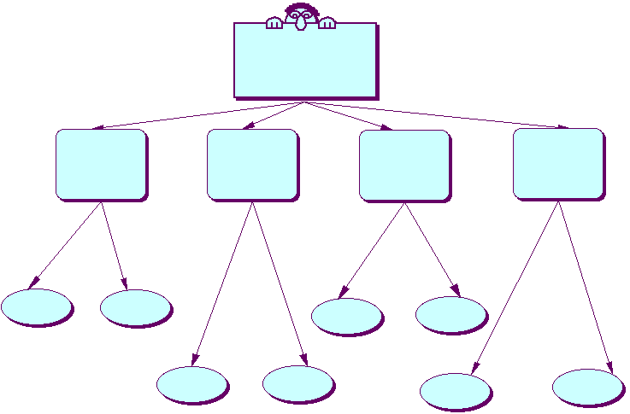
You can use a mind map, a Venn diagram, a grid, a color code… whatever helps you visualize your findings.

Find one essential/key idea that links all the documents—write it as your thesis statement or pose it as your guiding question, something you will demonstrate/prove/show during your commentary. Don’t forget that you will be helped in the instructions.

- ORGANISE YOUR IDEAS INTO AN OUTLINE:
  !!!! ORGANIZE BY IDEAS, NOT BY DOCUMENT!!!  DO THIS! |   DON’T DO THIS!
ORGANISE BY YOUR PERSONAL IDEAS  - Introduction: brief presentation of the documents + your guiding question or thesis statement + outline of your commentary  - Introduce idea 1 (the most obvious)  - Examples from all documents (explained/analyzed, linked/compared)  - Conclusion on first idea and transition to second idea  - Introduce idea 2 (the most original/personal)  - Examples from all documents (explained/analyzed, linked/compared)  - Conclusion: summary of your main ideas; “clincher” (finishing touch) /opening | ORGANISE BY DOCUMENT  - Introduction: direct question  - Summarize Document A  a. View on idea 1  b. View on idea 2  No transition  - Summarize Document B  - View on idea 1  - View on idea 2  - A one-sentence conclusion (starting with “to put it in a nutshell”)

- Note: write your conclusion and your introduction together, to have an overview of what your commentary will look like. You should know straight from the beginning what is the point of your demonstration.
D. MISCELLANEOUS
Introduction:
- The documents under study revolve around the idea of…
- We may wonder if / whether… (pas d’inversion SUJET / VERBE car question indirecte)
Outline :
- Use the pronoun you’re the most comfortable with. I/we…
- Introduce briefly your ideas catch the attention of the reader. For instance:
  - The following analysis will first tackle the issue of segregation in the USA, then in a second part on the heritage left by years of struggle, and finally, this essay aims at proving that even though segregation cannot be ignored nowadays, the tremendous amount of works of art has sparked hope in the land of milk and honey.
Core:
- 1 idea = 1 paragraph. Separate your thoughts. Even if your paragraph is short, let your text breathe.
- Keep in mind that the person reading your work might not have done better themselves, ok?
- Also, don’t write long sentences. Sharpening your style doesn’t mean writing for the sake of it.
- 1 main part, 2 or 3 ideas to develop. The title of your main parts should not contain a verb.
  - I. The shadow of segregation
    - A. A condemned race? = Doc A, B show that… Doc C insists even more…
    - B. A rotten seed = doc A and C were meant to denounce publicly… whereas doc B seems to have been censored… which reinforces the idea that…
  - II. The tinders of revolution
    - A. A change in the narrative = only DOC A shows… DOC B and C, given their nature, emphasize the idea that a conscious change was taking place.
    - B. Hope = the three documents refer to… even though it is not obvious in DOC A…
- DO NOT USE ABBREVIATIONS, prefer formal English.
- DO NOT USE EDGES “I think”, “maybe”, “perhaps”, “we can say that”, … Be assertive. Go straight to the point.
Conclusion:
- Re-write your ideas for your conclusion.
- It’s not easy to properly answer a research question. Thus, explain what you wanted to show in part 1 and part 2. For instance,
  - The first part of this essay shed light on the difficult relationship between history and memory: indeed, the history of segregation is still very much anchored in American society. Over time, the shared memory of African Americans has built itself upon this violent narrative which was sometimes regarded as a necessary evolution. And yet, as demonstrated in a second part, this memory should not be ignored but rather embraced: stories re-write history as it should have been told in the first place. A hundred-year long struggle for freedom.
- You can talk of another document that could have brought relevant precisions.
- Don’t be afraid of *shining* like a diamond. Be dramatic.

