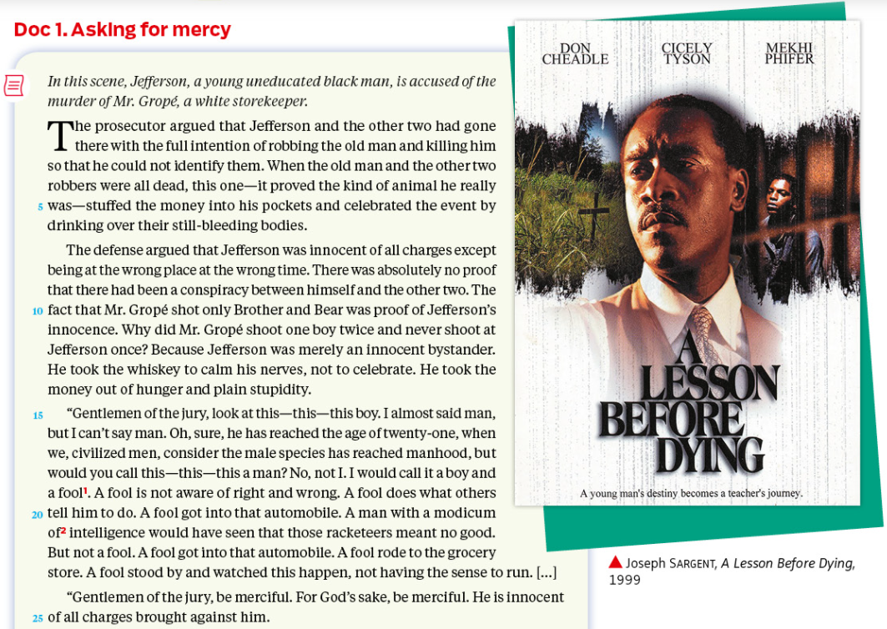
3 – Biased justice ?

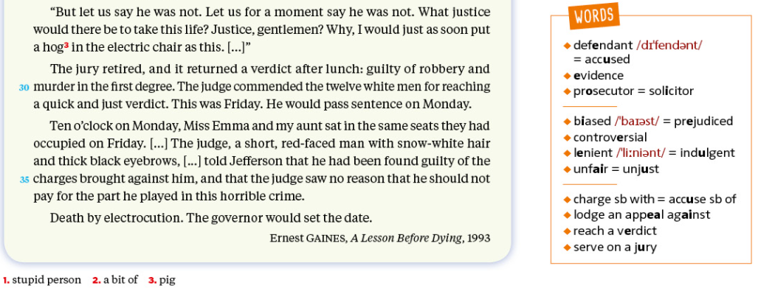

- Read the text and sum up the situation.
- Identify the 3 main parts of the text.
- Compare the prosecutor’s and defense’s versions of the story.
- Focus on the defense’s speech and pick out the words and expressions that dehumanize Jefferson. Explain his choice.
- Focus on the sentence “Death by electrocution. The governor would set the date.” l.37
  - What is the point of view, here? (Type of narration, speech)
  - How does this convey Jefferson’s feelings?
- Pay attention to the composition of the court and discuss the questions it raises.

