U2L2 / IRISH LEGENDS – / p30 / 

tip ► You always have to pay attention to the structure of a text.

Look at the title and its typography. What does it evoke to you ? It evokes a legend (the word itself & the typo).
Number the paragraphs. 5 / Name the first and last paragraph = introduction & conclusion
Now, circle the first words of paragraphs 1, 2, 3 & 4. ► They give a structure.

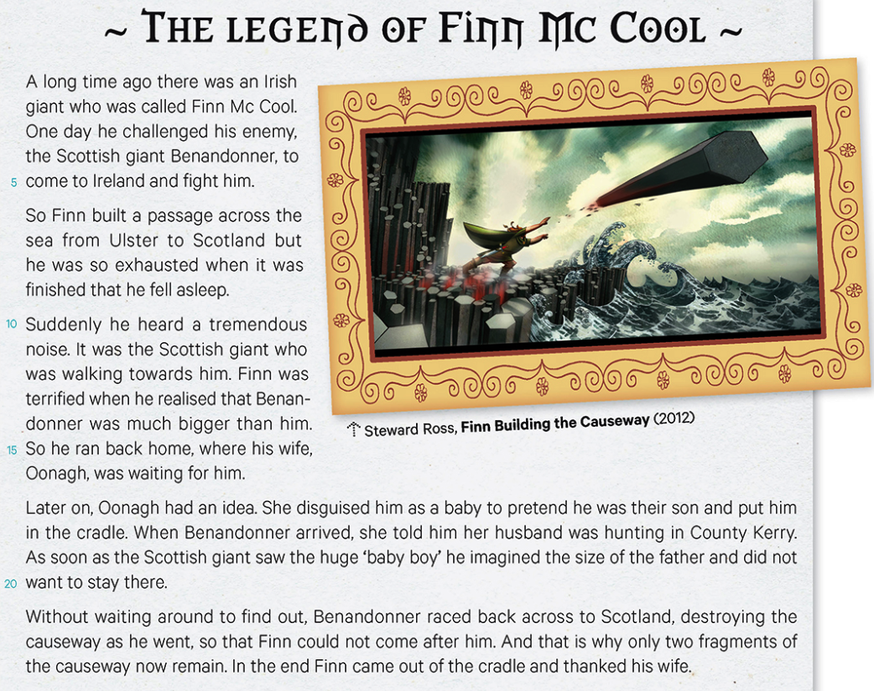

a/ Focus on the 1st paragraph. Highlight in yellow and green the name and nationalities of each character.
Complete () the map below with the information you’ve found out in the text.
Benandonner
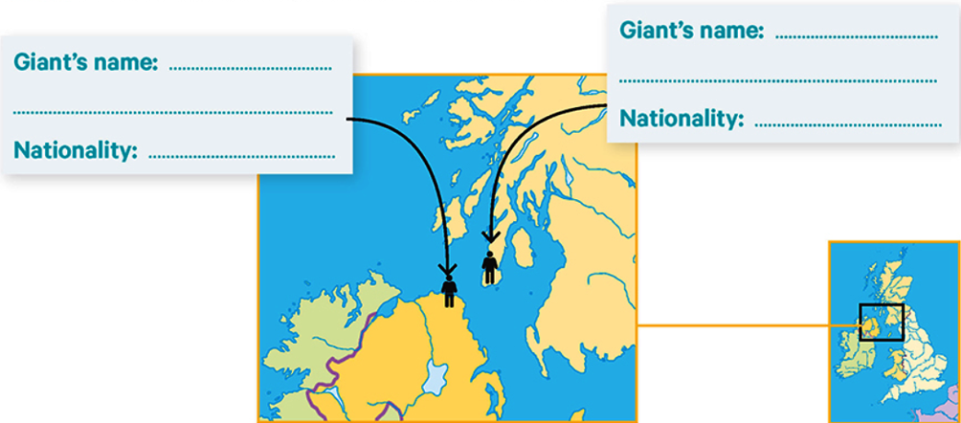
Irish
Scottish
Finn
Oonagh is Finn’s wife.

Find () two words expressing the idea of confrontation. ► challenged (l.3) & fight (l.5)

c/ Read the text and number () the pictures in the right order by sticking (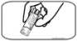) them at the back of your paper. ► See corrigé à part

d/ Read () paragraphs 2, 3 & 4 and complete () the chart. You must use the preterit.
Finn’s first reaction | Benandonner’s response |  | Finn’s problem  + why |  | Finn’s reaction
He built a passage across the sea from Ulster to Scotland. | He walked to meet Finn. |  | He was terrified because Benandonner was much bigger than him. |  | He ran back home.
Oonagh’s idea |  | Benandonner’s reaction (2) |  | condition of the causeway
Her idea was to disguise Finn as a baby then to pretend he was their son (and tell Benandonner Finn was hunting in the County Kerry). |  | When he saw the huge baby, he imagined the size of the father and so was frightened / scared. So he ran away. |  | When he ran away, he destroyed the Causeway.
Why did Benandonner destroy the Causeway ? He destroyed it because he was too scared of Finn’s size. As a result, Finn could not come after him to find him.

f/ Sum up orally the legend of Finn McCool. ► Servira de base pour la TE.

g/ Boost your vocabulary. IN THE TEXT, find () the English for the following words;
défier | chasser | énorme (x2) | la taille | un berceau | rester | épuisé
to challenge  (l.3) | hunt  (l.18) | tremendous (l.10) / huge (l.19) | the size  (l.19) | a cradle  (l.18/23) | to remain  (l.23) | exhausted  (l.8)

h/ Repérages grammaticaux.
► Surligne en bleu dans le texte les subordonnées de temps. (5)
► Lis et complète l’activité dans ton WB p29 (les subordonnées de temps)

► Surligne en orange dans le texte les connecteurs logiques puis complète le tableau à l’aide de tes réponses.
et c’est pourquoi | donc | mais | sans | si bien que
and that is why  (l.22) | so  (l.6 + l.15) | but  (l.7) | without (+ V-ing)  (l.21) | so that  (l.22)

► Surligne en rose dans le texte les connecteurs temporels puis complète le tableau à l’aide de tes réponses.
à la fin / finalement | un jour | plus tard | soudainement | il y a longtemps | dès que | alors que / tandis que
in the end  (l.23) | one day  (l.3) | later on  (l.17) | suddenly  (l.10) | a long time ago (l.1) | as soon as  (l.19) | as  (l.22)
► Lis et complète l’activité dans ton WB p28 (les connecteurs logiques)

► Encadre en noir dans le texte les prétérits en BE + ING. Réécris les phrases dans lesquelles ils se trouvent et traduis-les.

tip ► le prétérit en be + ing comporte toujours deux mots ► l’auxiliaire was ou were + un verbe en –ing.

1 Suddenly, he heard a tremendous noise, it was the Scottish giant who was walking towards him. (l.10-12)
► Soudain, il entendit un bruit énorme : c’était le géant qui marchait dans sa direction / vers lui.

2 So, he ran back home, where his wife, Oonagh, was waiting for him. (l.15-16)
► Alors, il rentra chez lui, où sa femme, Oonagh, l’attendait.

3 When Benandonner arrived, she told him her husband was hunting in County Kerry. (l.18)
► Quand Benandonner arriva, elle lui raconta que son mari chassait à County Kerry / était parti chasser à County Kerry.
► Lis et complète l’activité dans ton WB p26 (le prétérit simple et le prétérit en be + V-ing)

i/  ► Do the activities in your book p33 n°3 + 4 + 5 (lire et faire les exercices dans le classeur).

