U2L2 / Boost Your Grammar ()
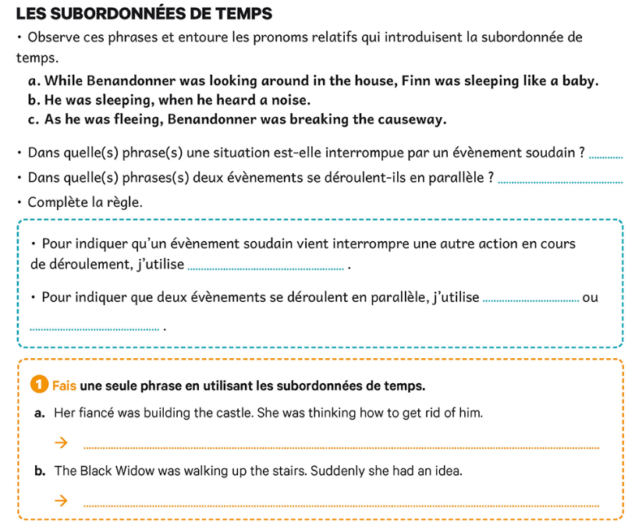
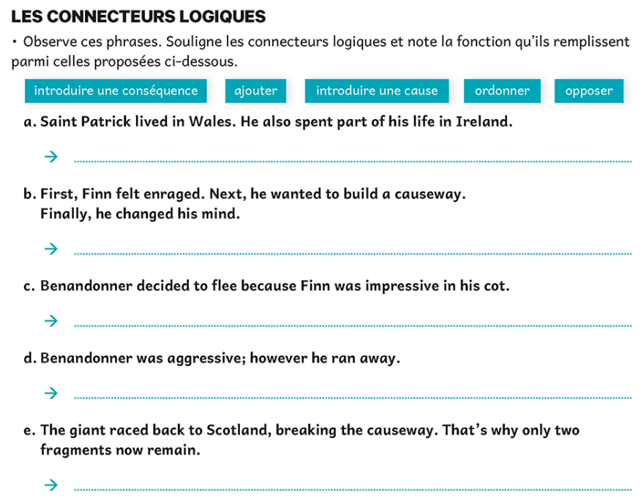
► Complète ce récit avec les linkwords as, therefore, however, next ou so. Plusieurs solutions sont parfois possibles.

First, we made our way to Banagher to see the remains of St Murroug O’ Heaney. _____________ we headed to Ardee. This is a picture of Trim Castle, where you can find salmon. _____________ the Salmon of Knowledge is gone by now ! My family loved the place _____________ we stayed longer. It was raining heavily _____________ I sat down in a nice pub. Look, it’s me on the picture ! Can you tell I was really cold ?

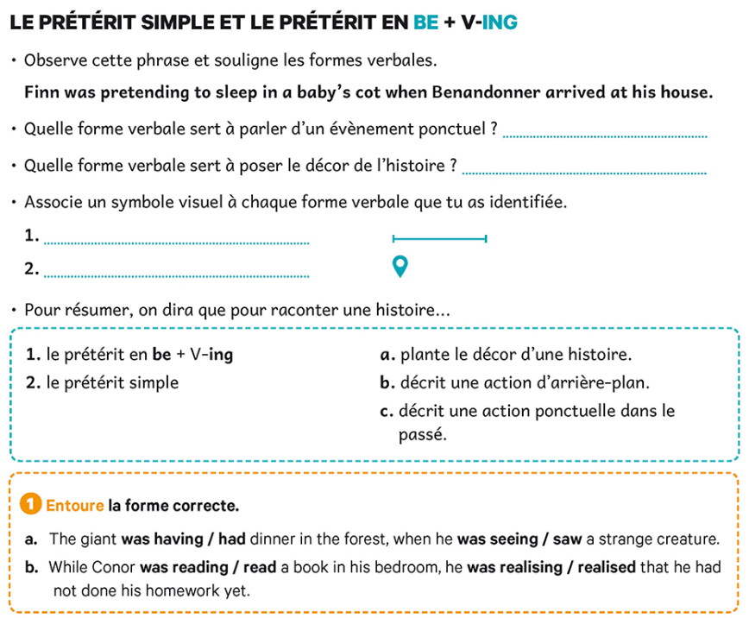

Write () here the meaning of difficult vocab from the activities.

